# การวิเคราะห์การใช้ไฟฟ้า

รายงานนี้ประกอบด้วยการวิเคราะห์พฤติกรรมการใช้ไฟฟ้าและการติดตั้งโซล่าเซลล์.

## Images from Result

Image: anual_load.png

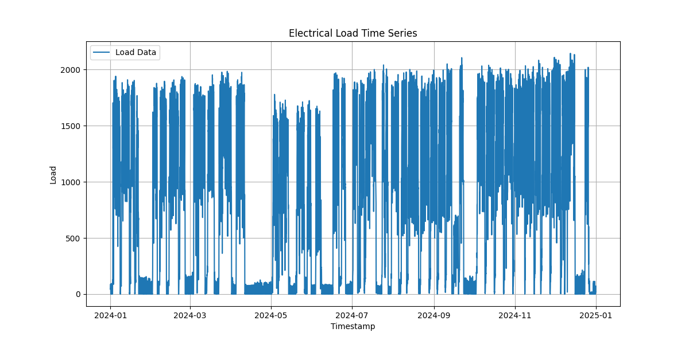

Image: average_load_every_day.png

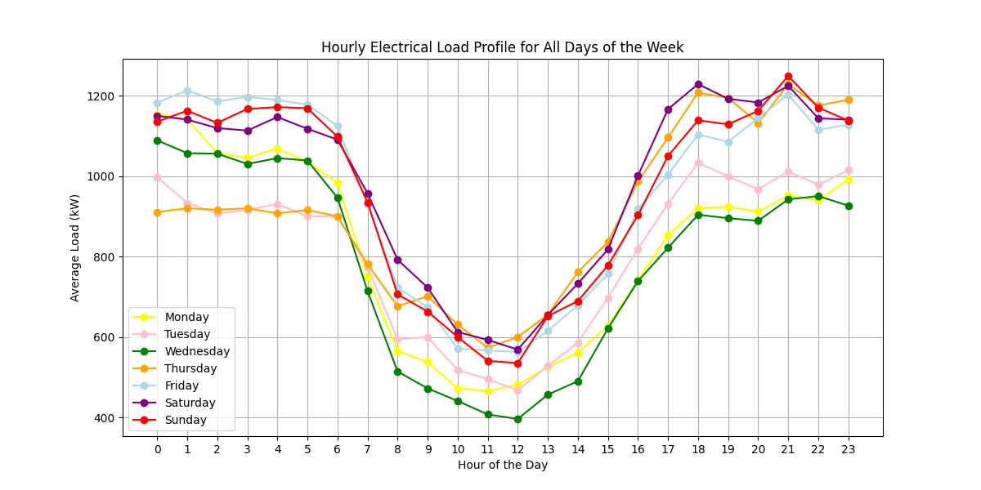

Image: average_weekday_weekend.png

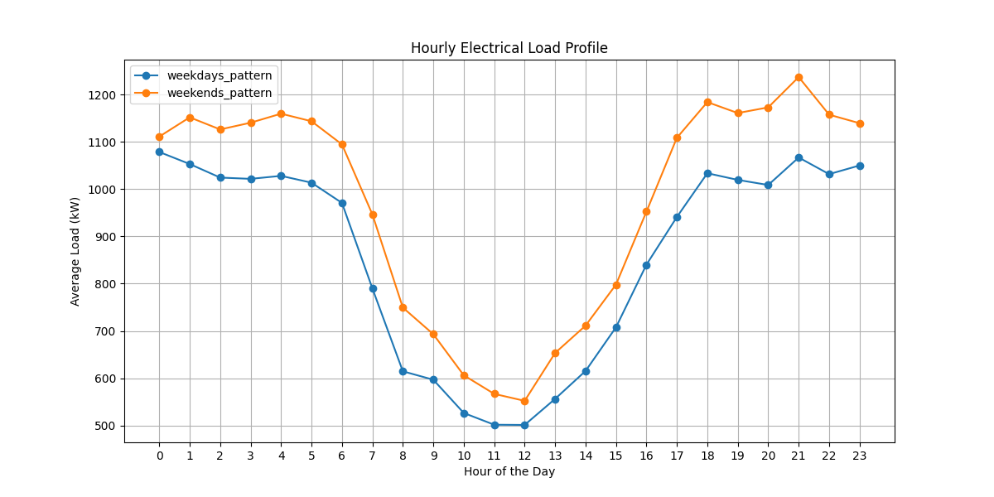

Image: LoadVariation.png

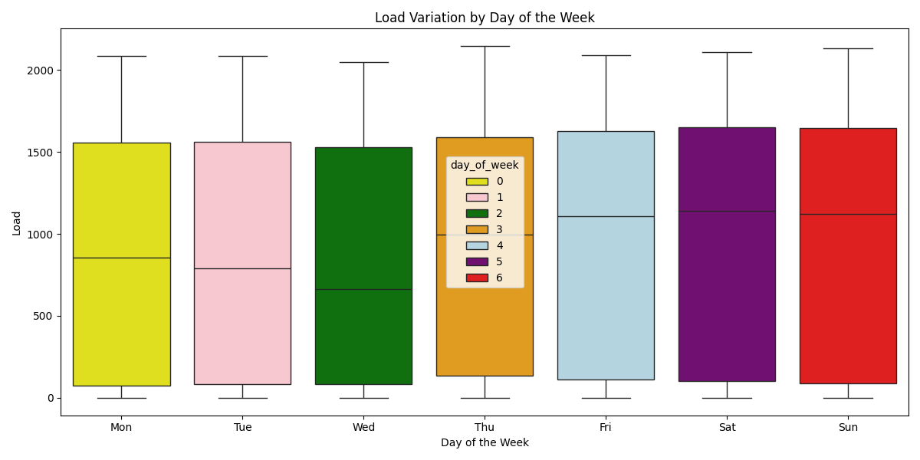

Image: Load_and_PV(1,000_kWp)_10_October.png

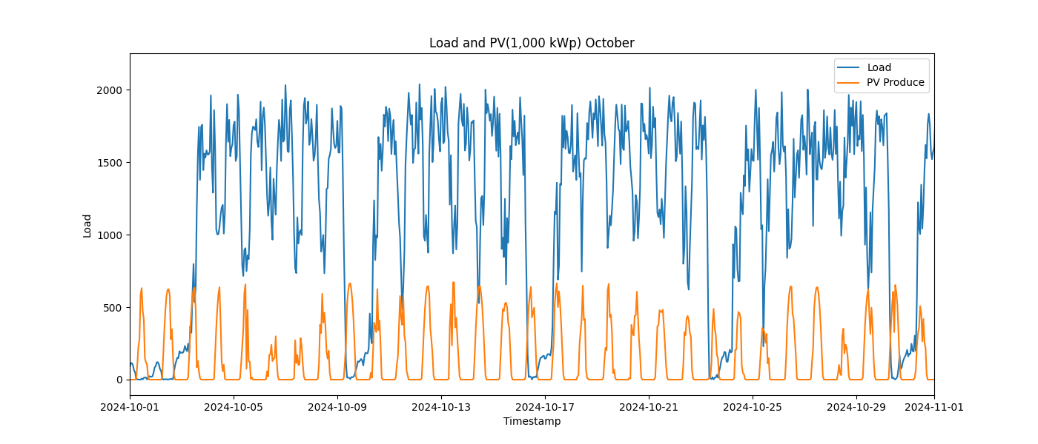

Image: Load_and_PV(1,000_kWp)_11_November.png

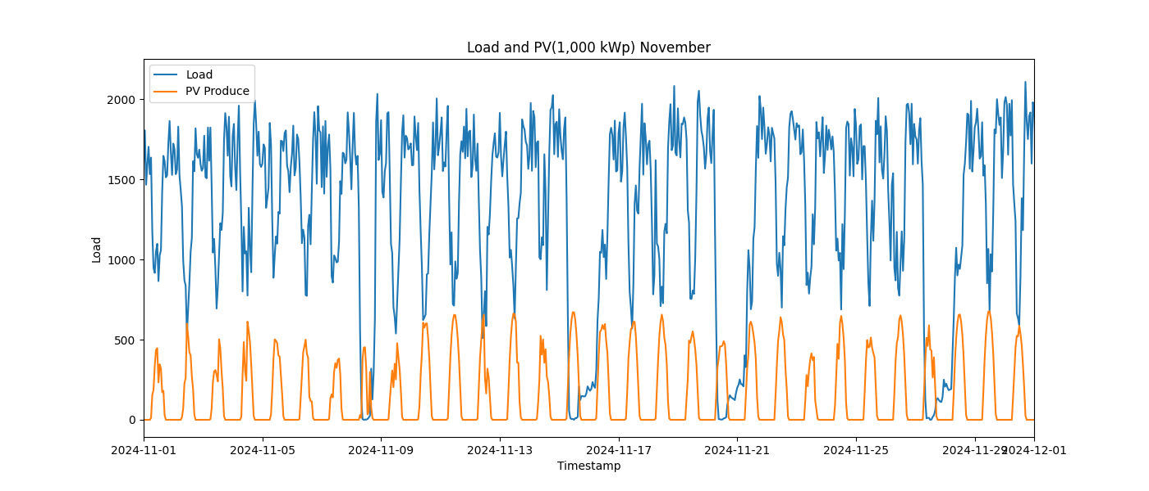

Image: Load_and_PV(1,000_kWp)_12_December.png

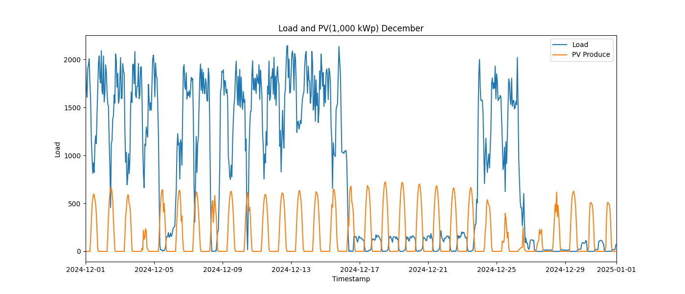

Image: Load_and_PV(1,000_kWp)_1_January.png

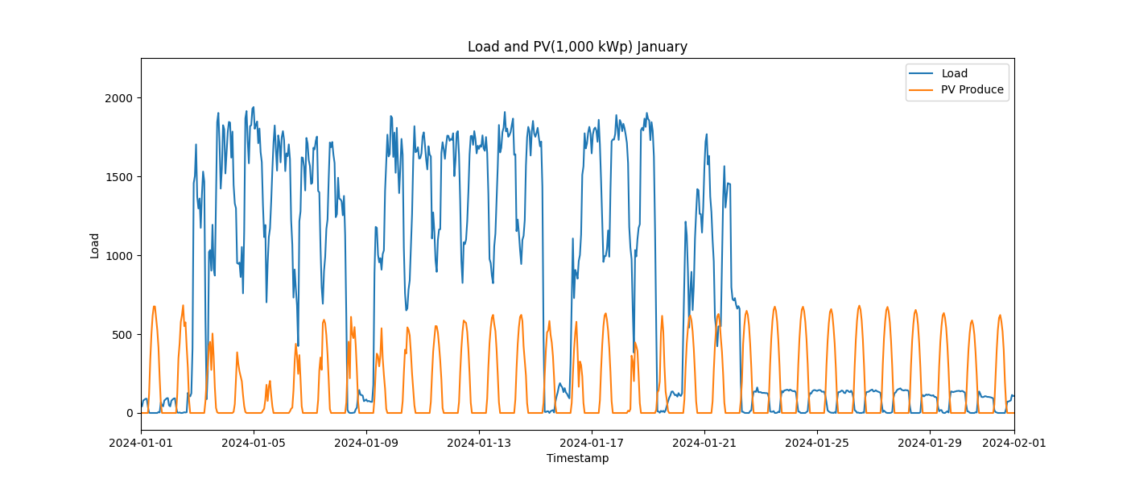

Image: Load_and_PV(1,000_kWp)_2_February.png

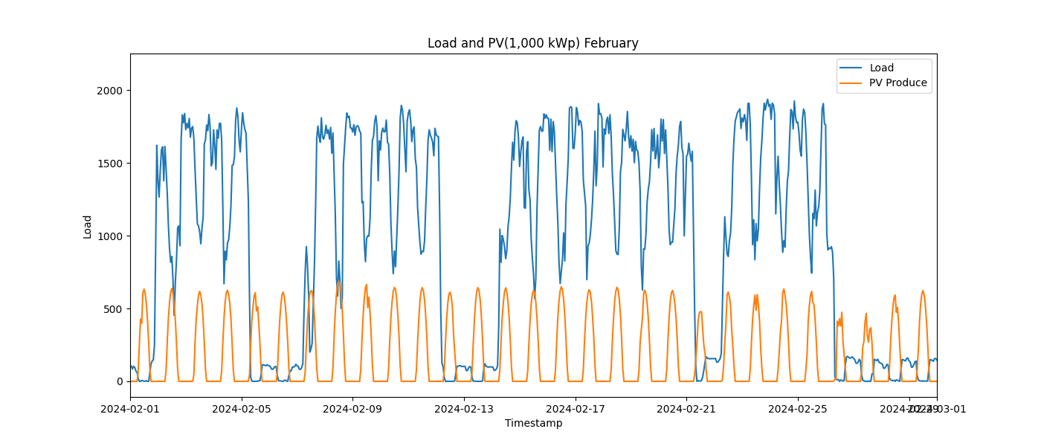

Image: Load_and_PV(1,000_kWp)_3_March.png

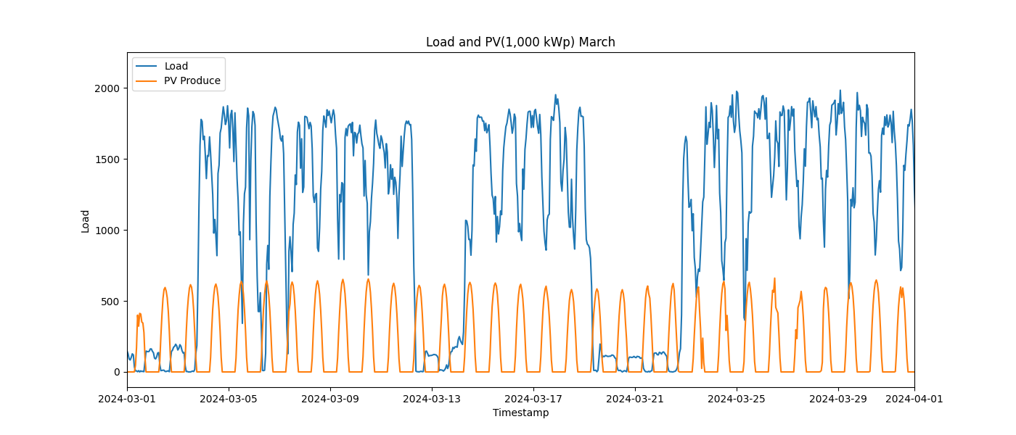

Image: Load_and_PV(1,000_kWp)_4_April.png

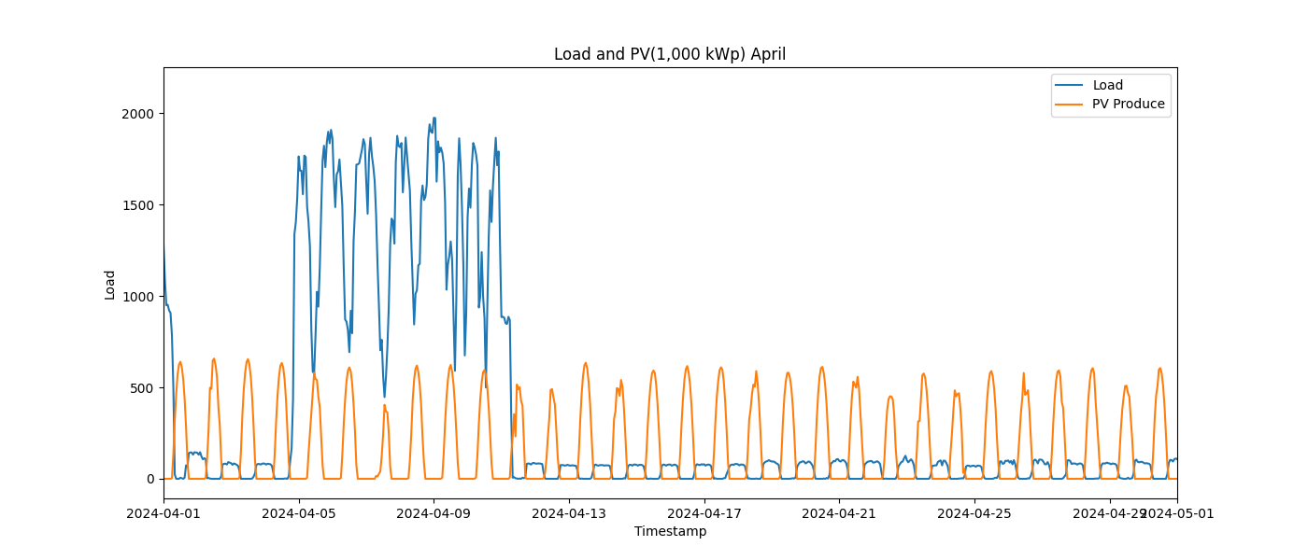

Image: Load_and_PV(1,000_kWp)_5_May.png

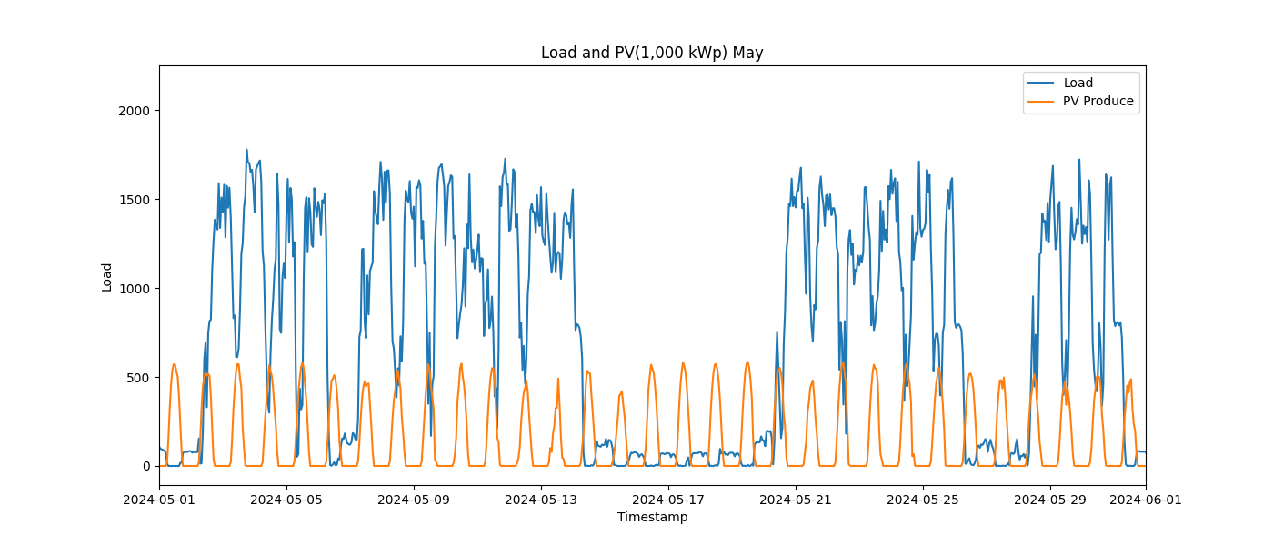

Image: Load_and_PV(1,000_kWp)_6_June.png

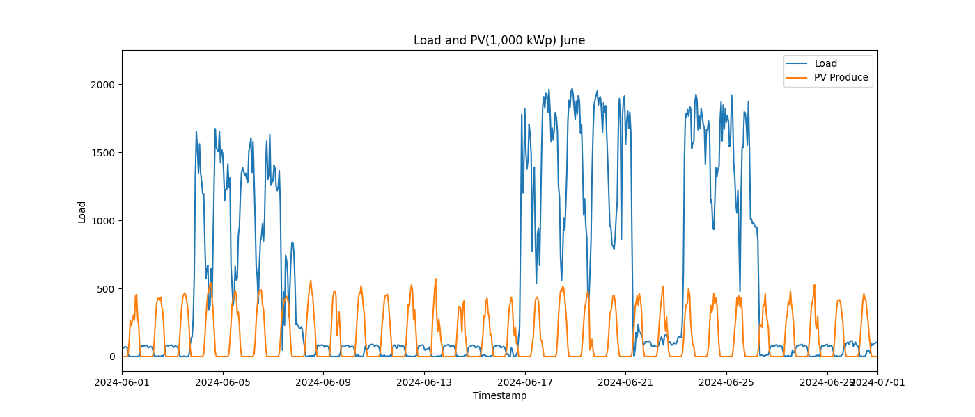

Image: Load_and_PV(1,000_kWp)_7_July.png

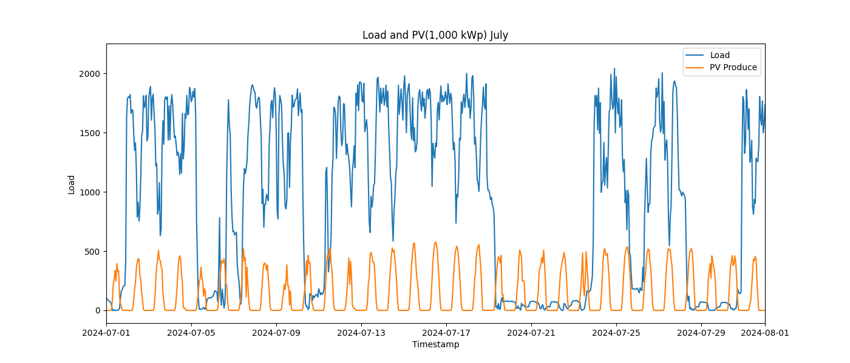

Image: Load_and_PV(1,000_kWp)_8_August.png

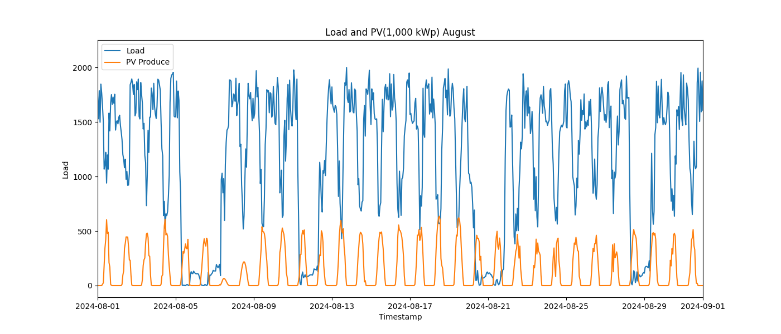

Image: Load_and_PV(1,000_kWp)_9_September.png

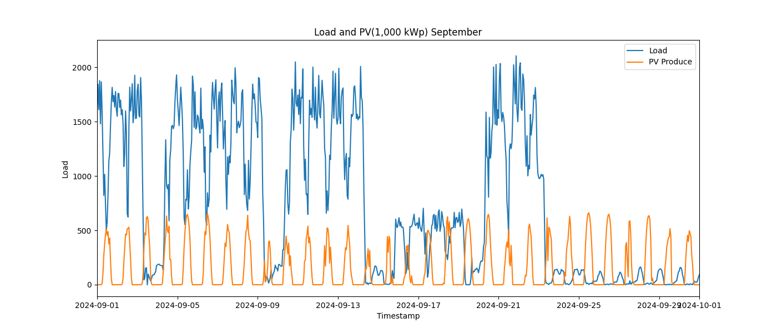

Image: Load_and_PV(100_kWp)_10_October.png

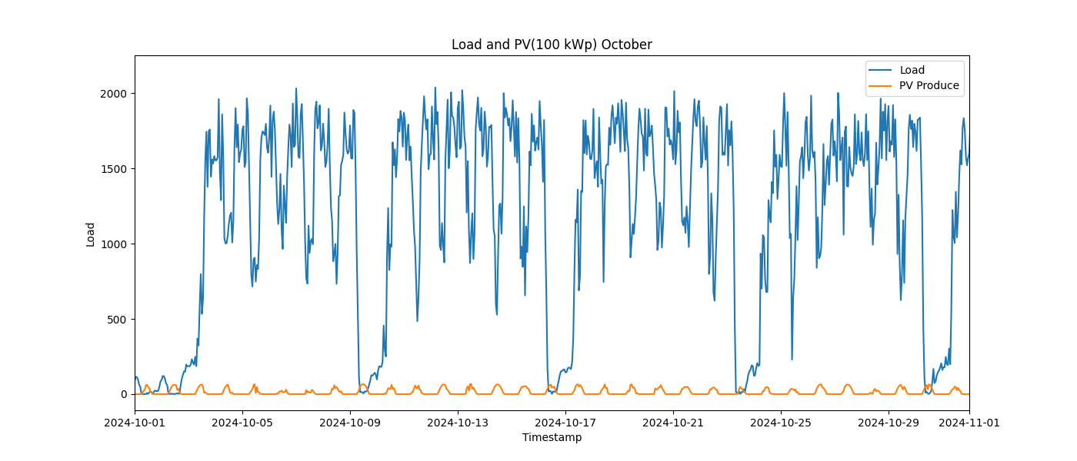

Image: Load_and_PV(100_kWp)_11_November.png

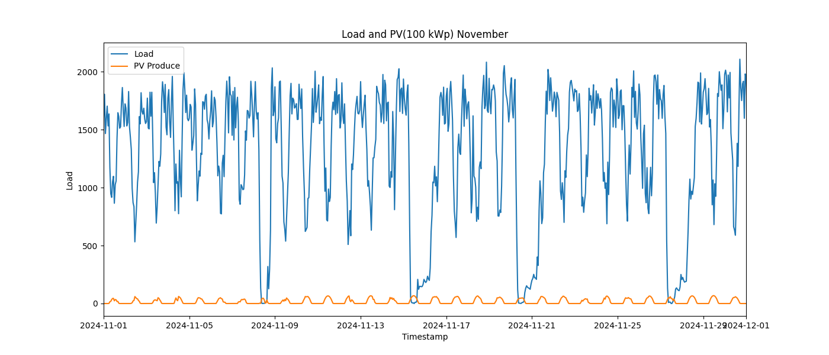

Image: Load_and_PV(100_kWp)_12_December.png

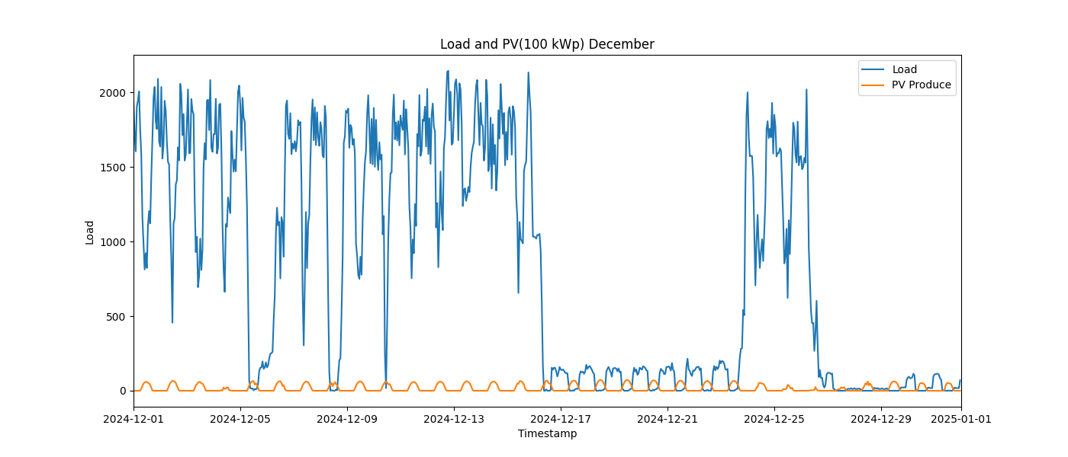

Image: Load_and_PV(100_kWp)_1_January.png

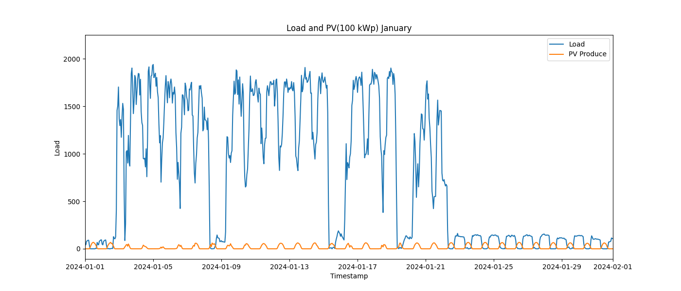

Image: Load_and_PV(100_kWp)_2_February.png

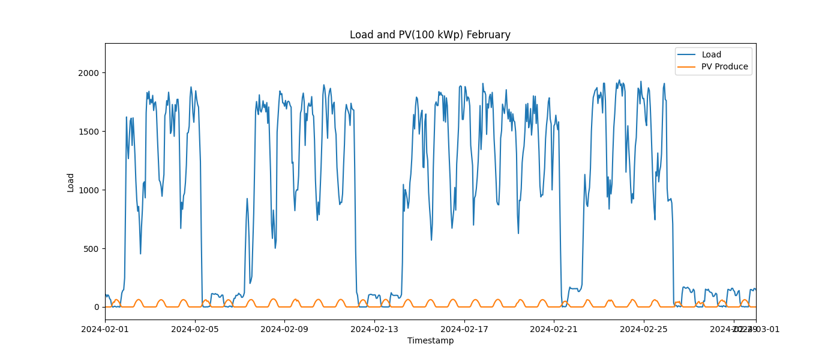

Image: Load_and_PV(100_kWp)_3_March.png

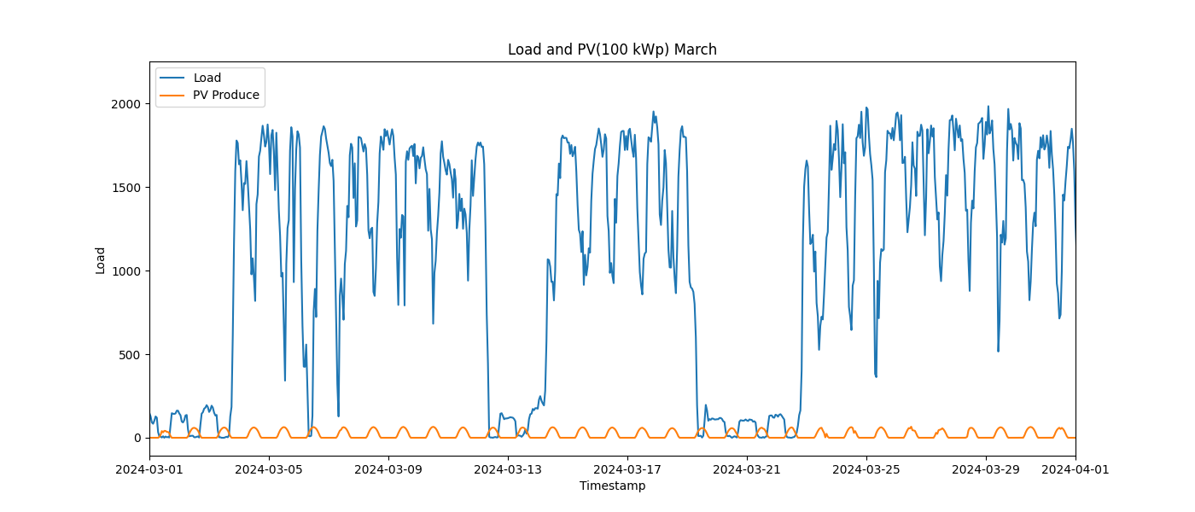

Image: Load_and_PV(100_kWp)_4_April.png

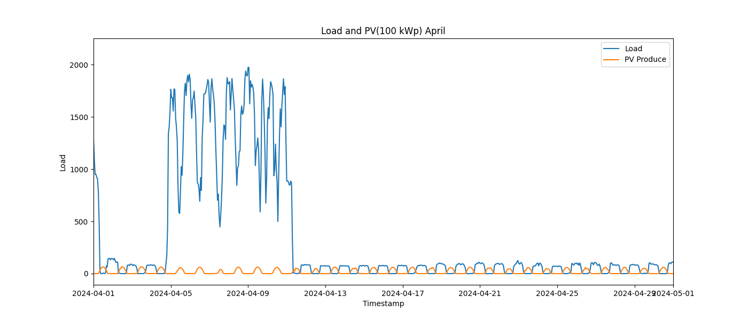

Image: Load_and_PV(100_kWp)_5_May.png

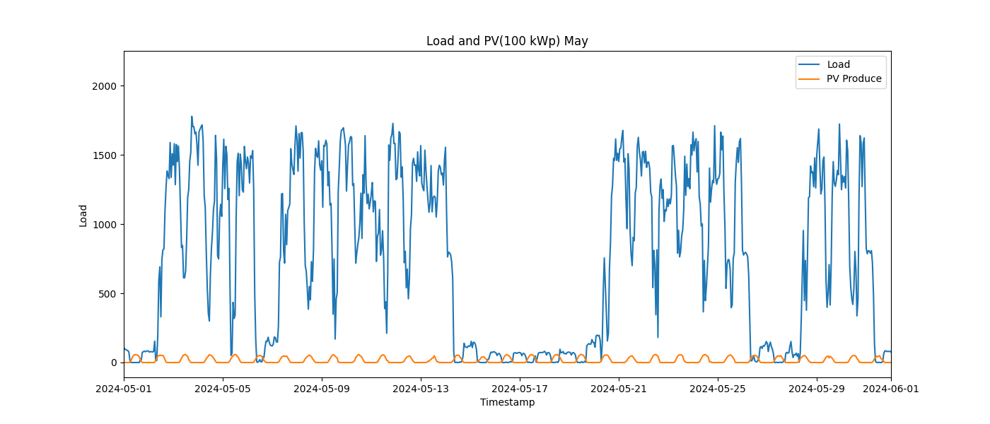

Image: Load_and_PV(100_kWp)_6_June.png

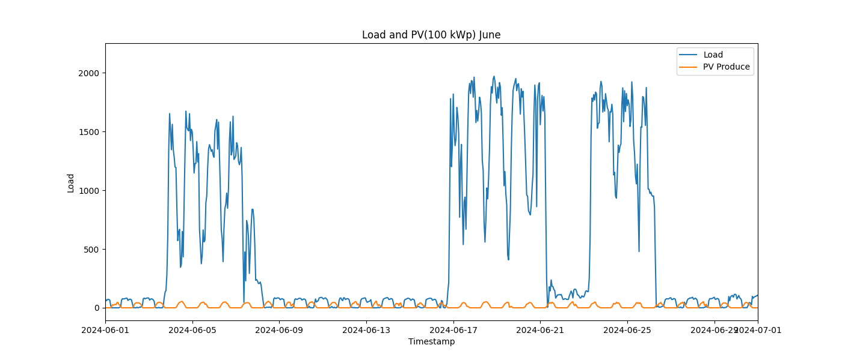

Image: Load_and_PV(100_kWp)_7_July.png

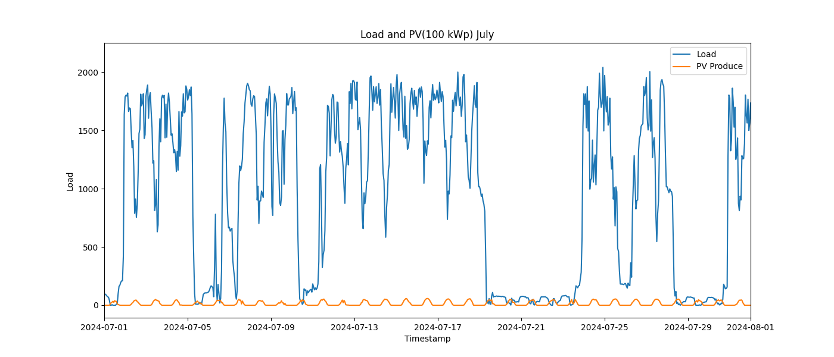

Image: Load_and_PV(100_kWp)_8_August.png

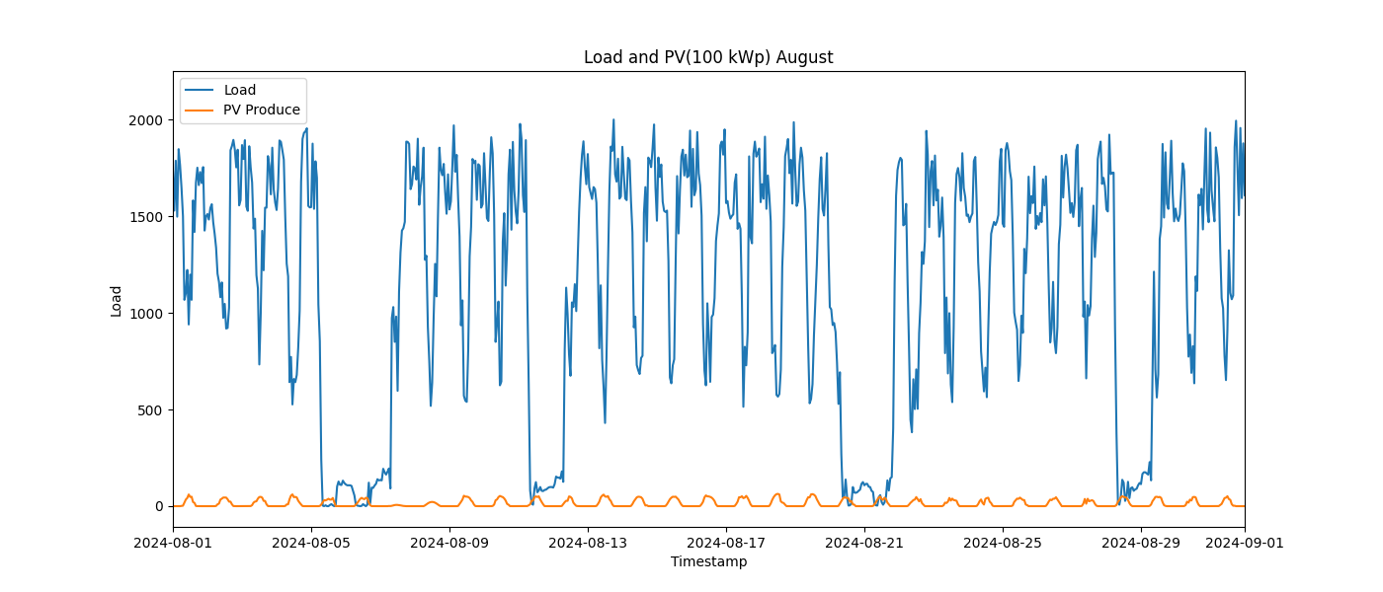

Image: Load_and_PV(100_kWp)_9_September.png

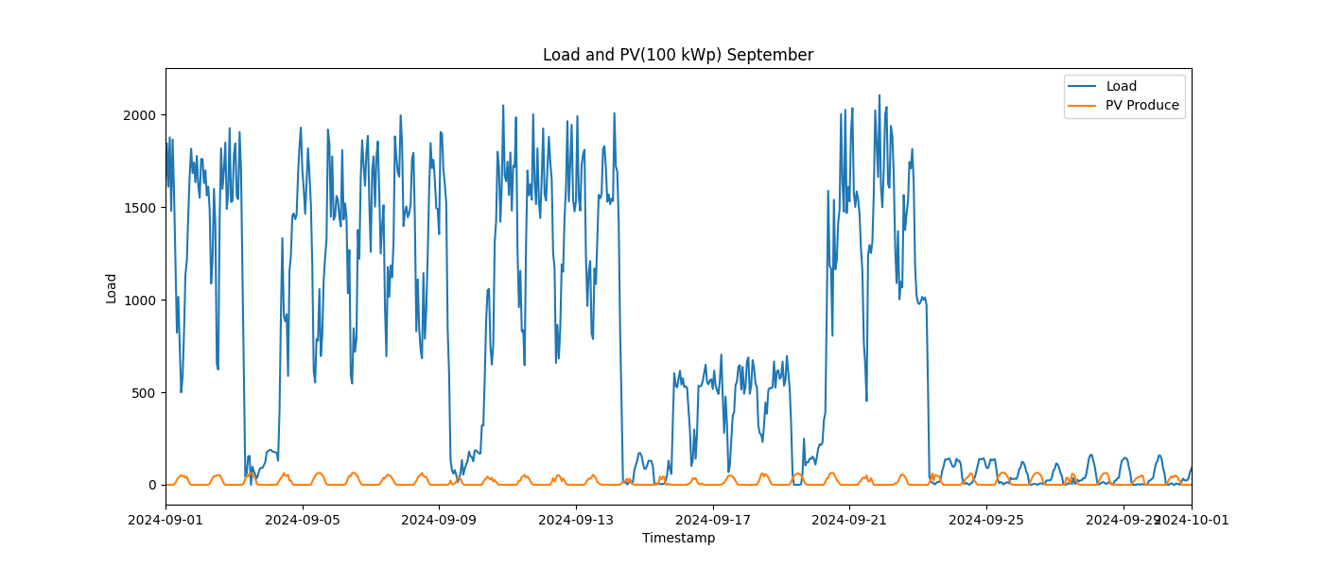

Image: Load_and_PV(500_kWp)_10_October.png

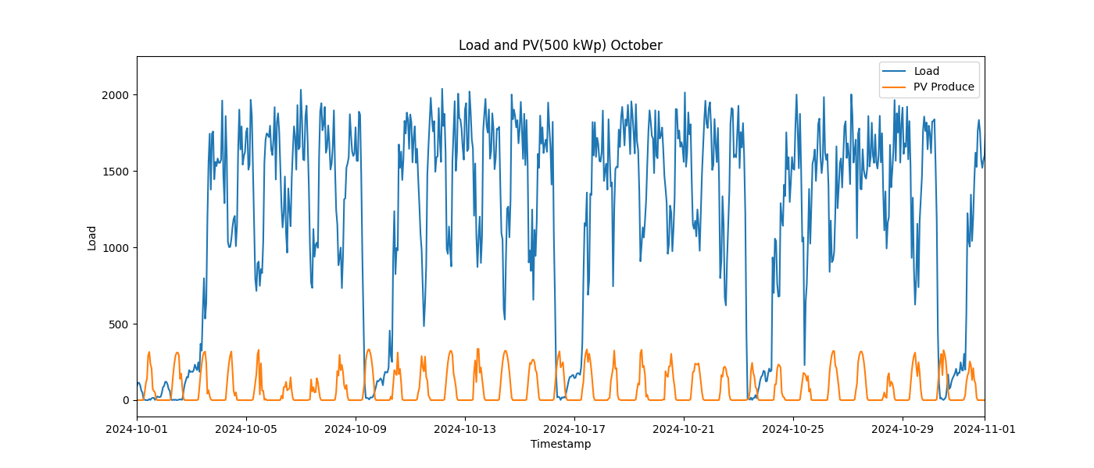

Image: Load_and_PV(500_kWp)_11_November.png

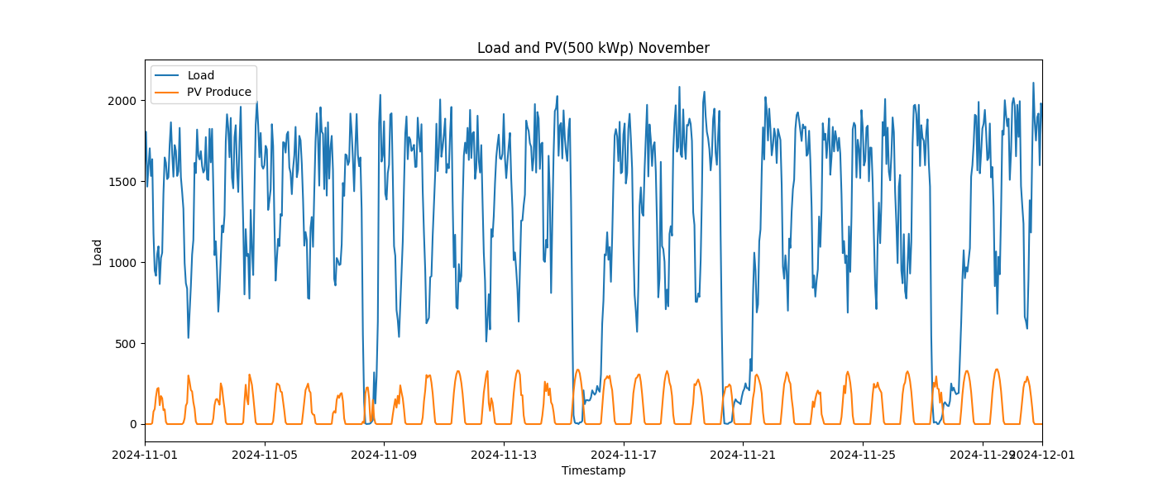

Image: Load_and_PV(500_kWp)_12_December.png

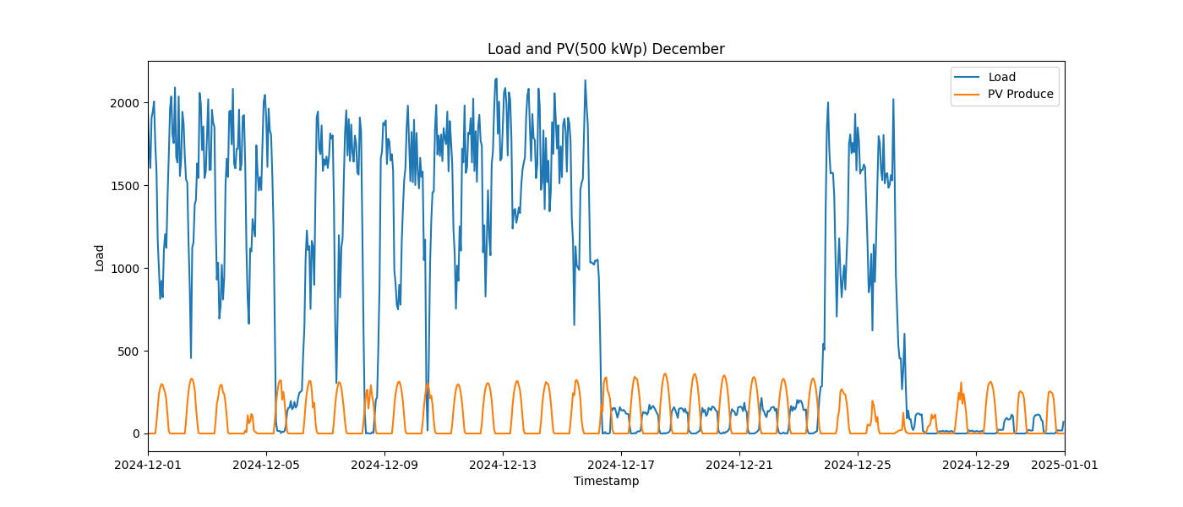

Image: Load_and_PV(500_kWp)_1_January.png

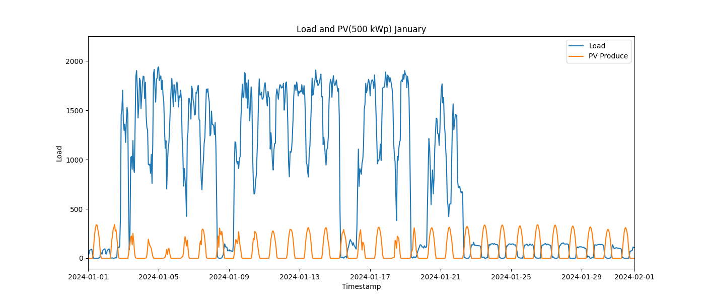

Image: Load_and_PV(500_kWp)_2_February.png

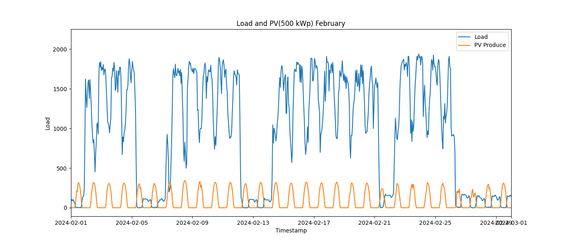

Image: Load_and_PV(500_kWp)_3_March.png

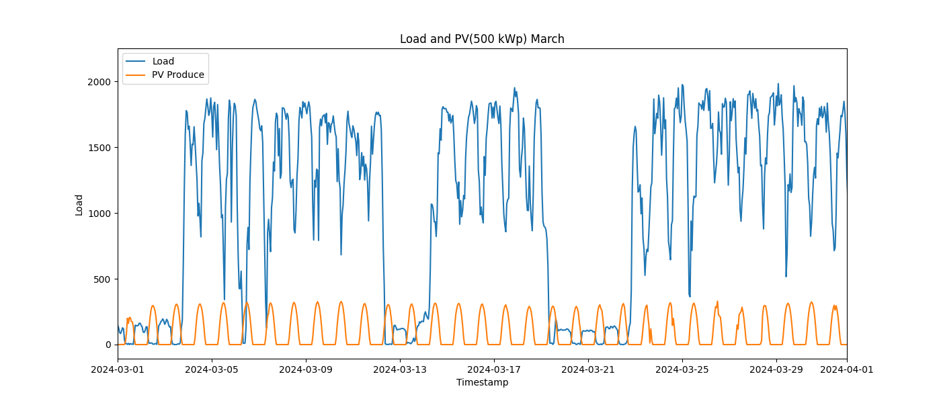

Image: Load_and_PV(500_kWp)_4_April.png

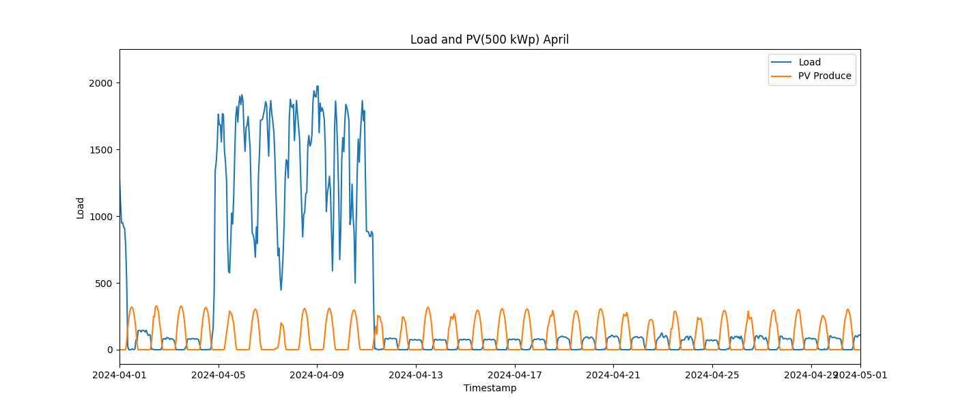

Image: Load_and_PV(500_kWp)_5_May.png

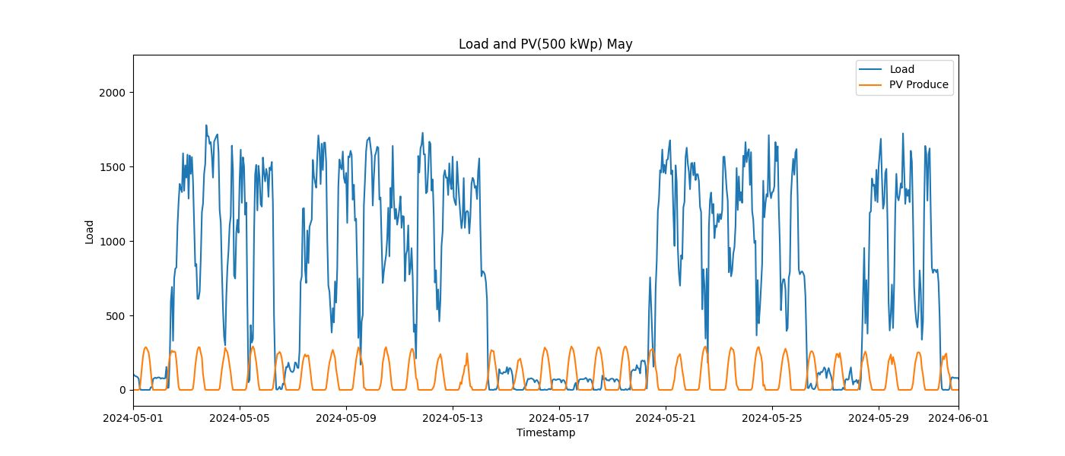

Image: Load_and_PV(500_kWp)_6_June.png

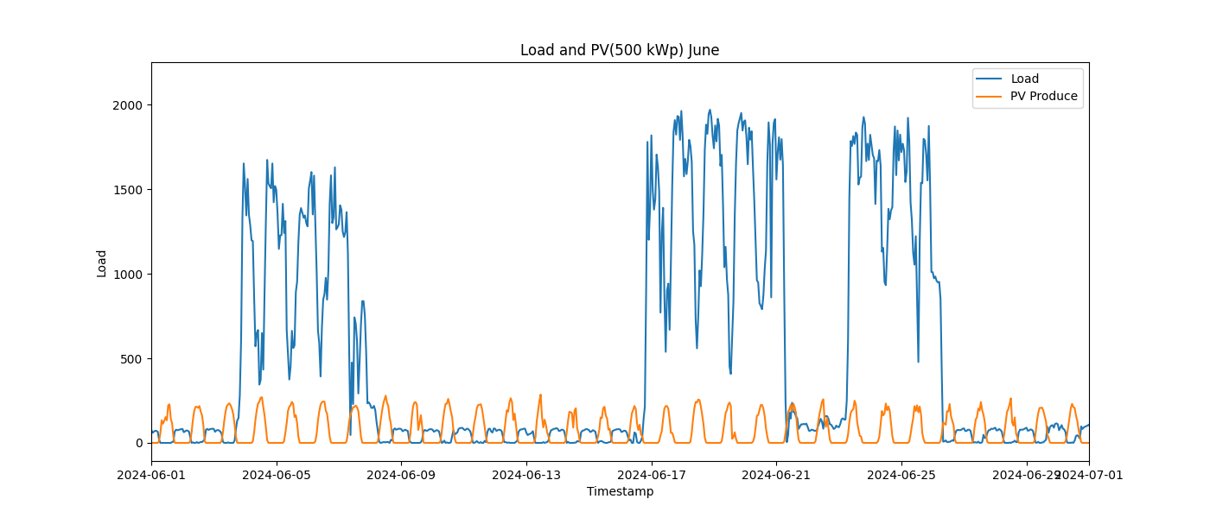

Image: Load_and_PV(500_kWp)_7_July.png

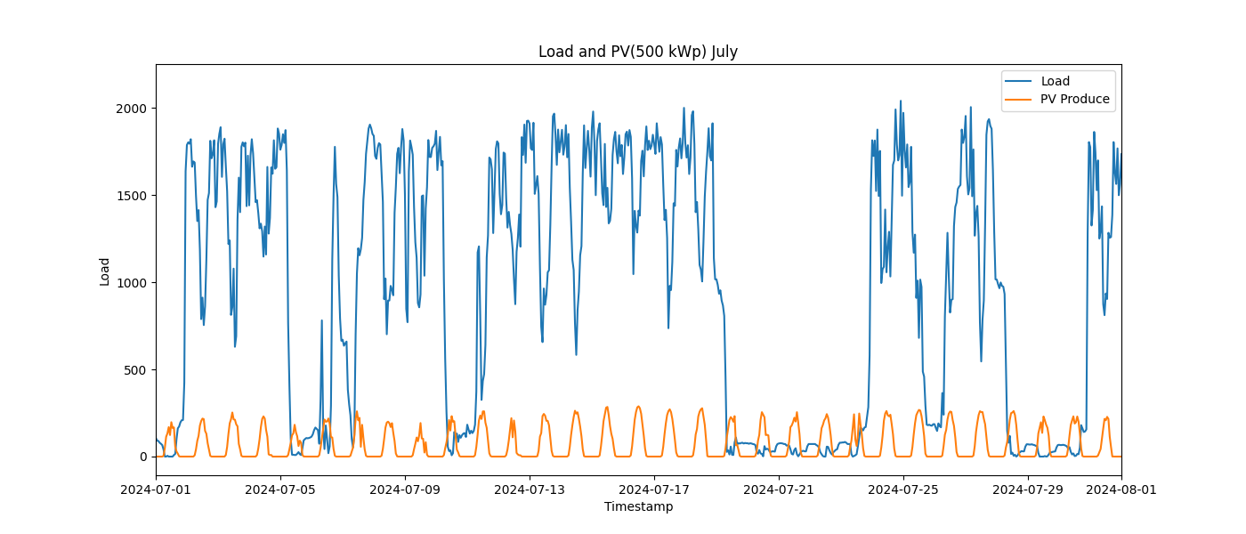

Image: Load_and_PV(500_kWp)_8_August.png

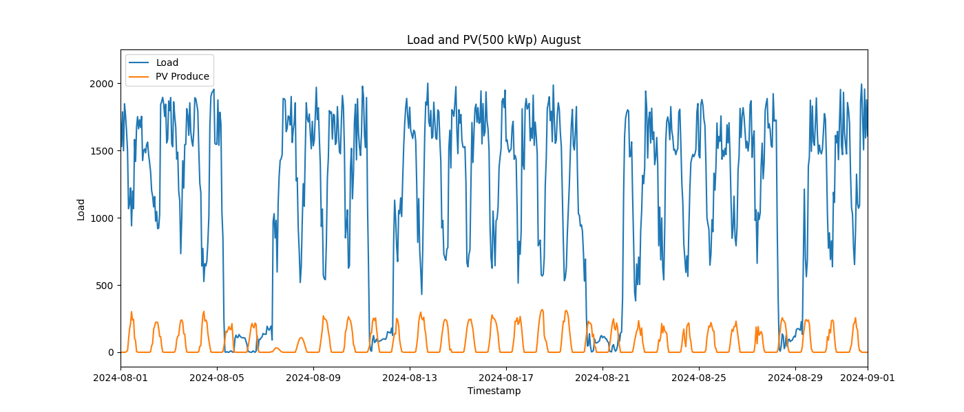

Image: Load_and_PV(500_kWp)_9_September.png

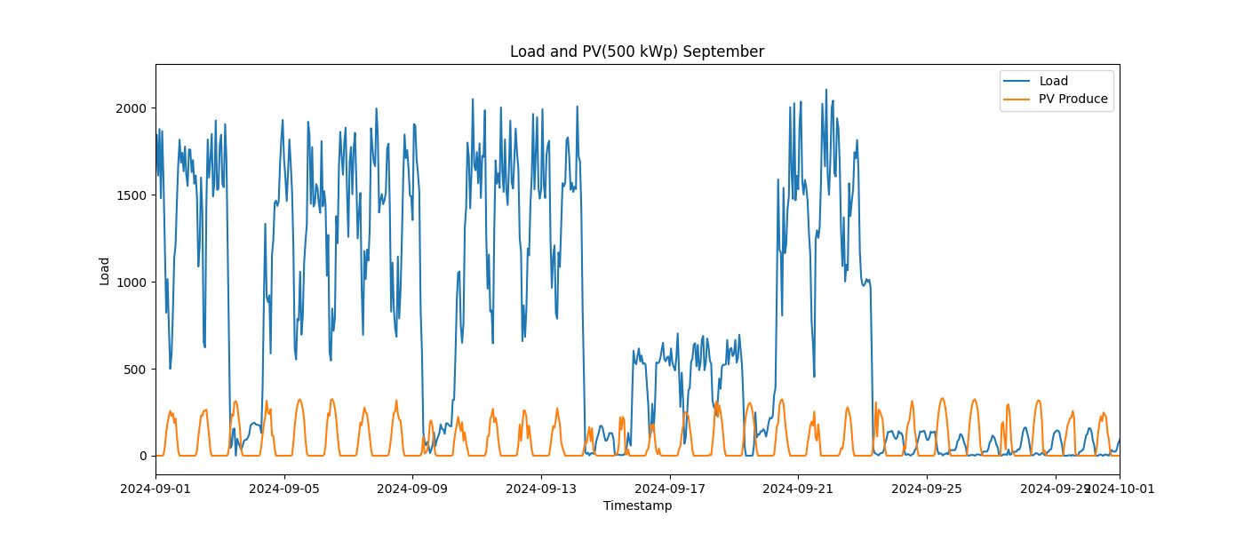

Image: load_distribution.png

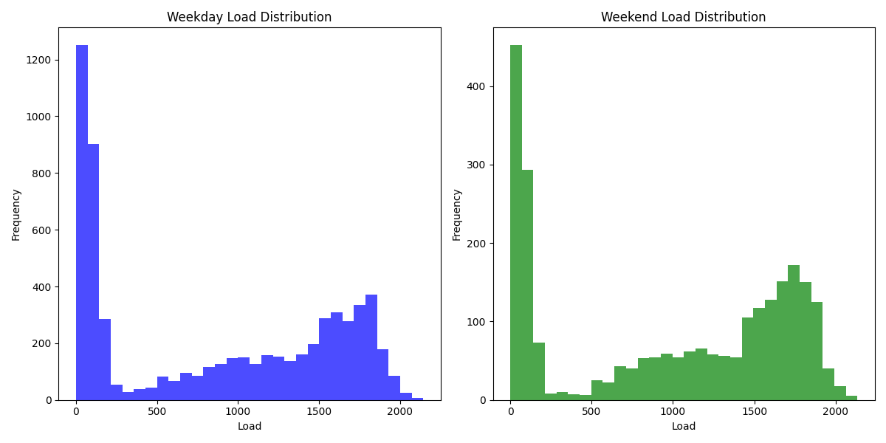

Image: load_duration_curve_all_days.png

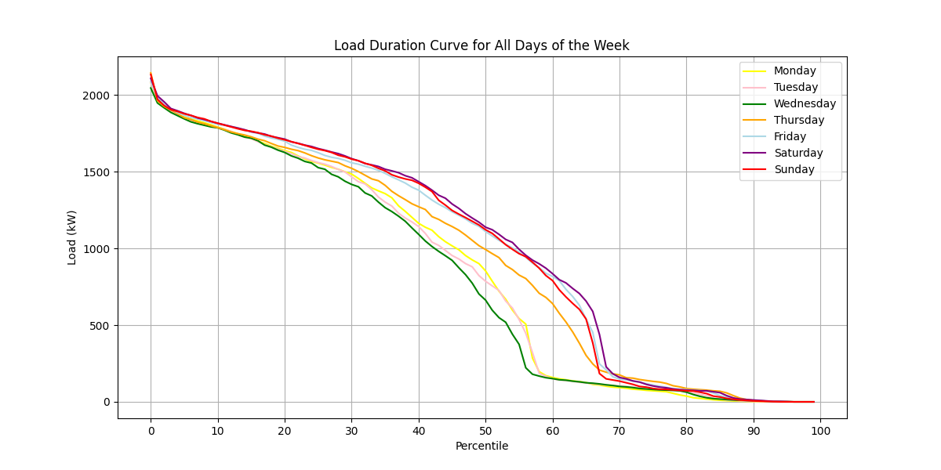

Image: load_duration_curve_all_months.png

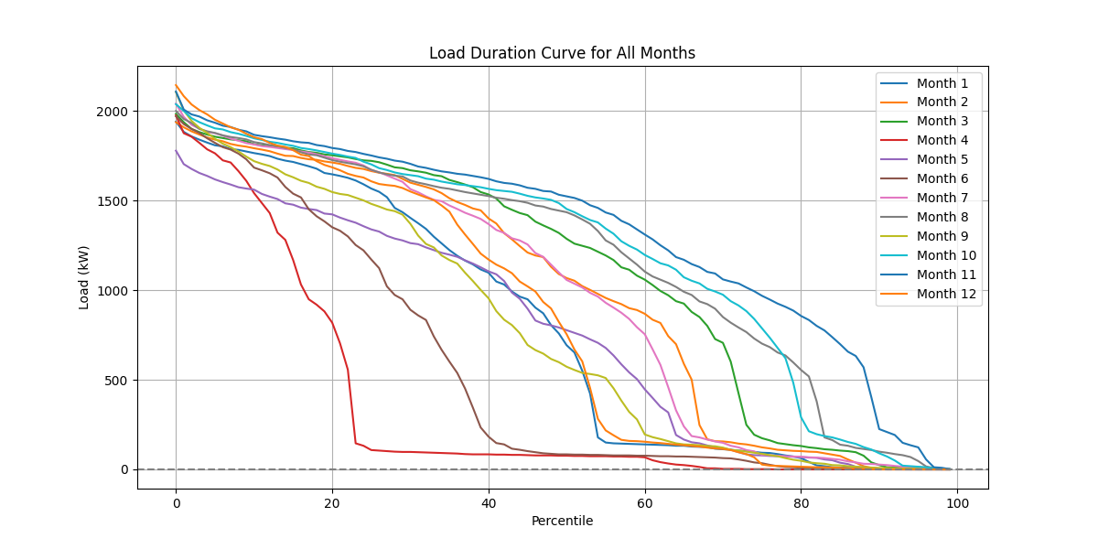

Image: load_duration_curve_weekdays_weekends.png

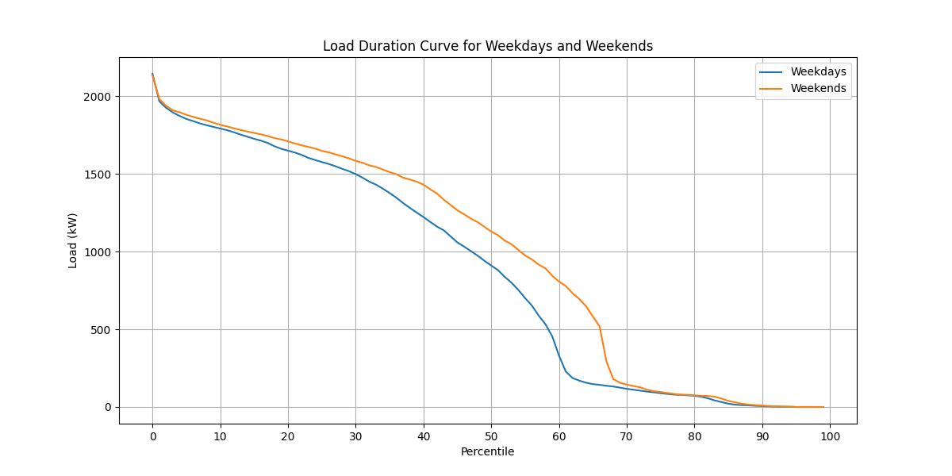

Image: load_pv(1,000_kWp).png

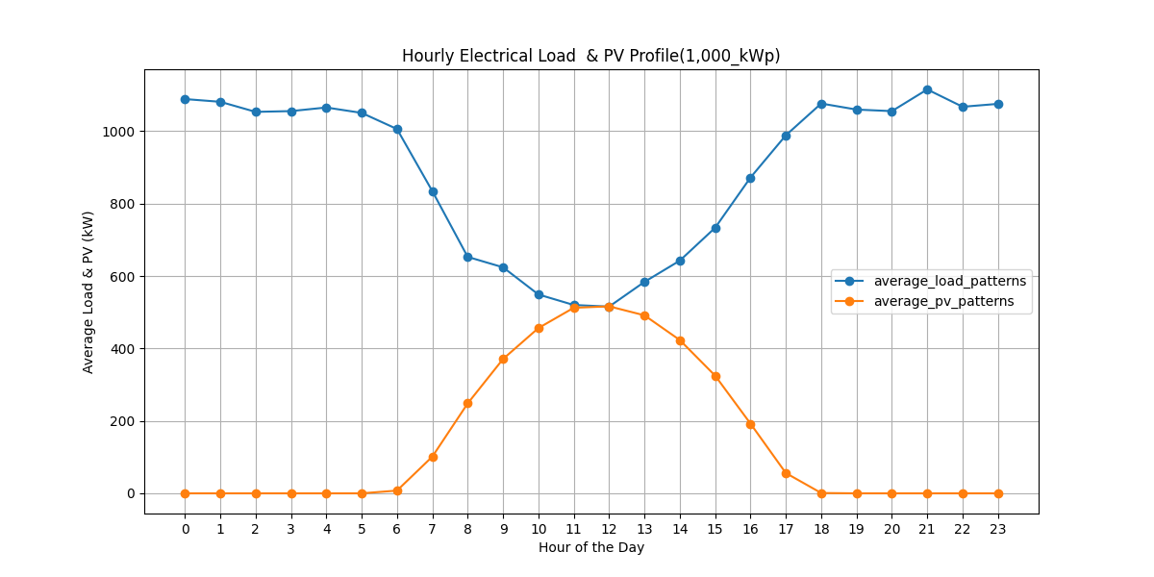

Image: load_pv(100_kWp).png

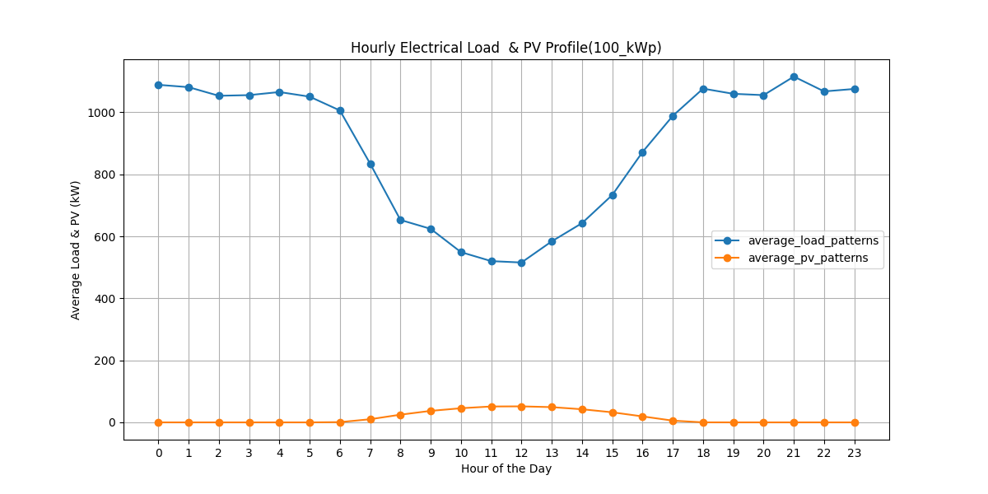

Image: load_pv(500_kWp).png

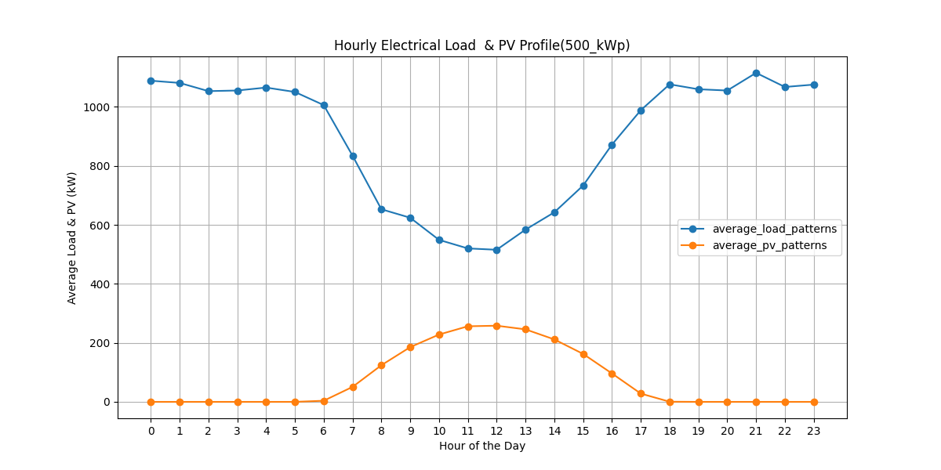

Image: peak_day.png

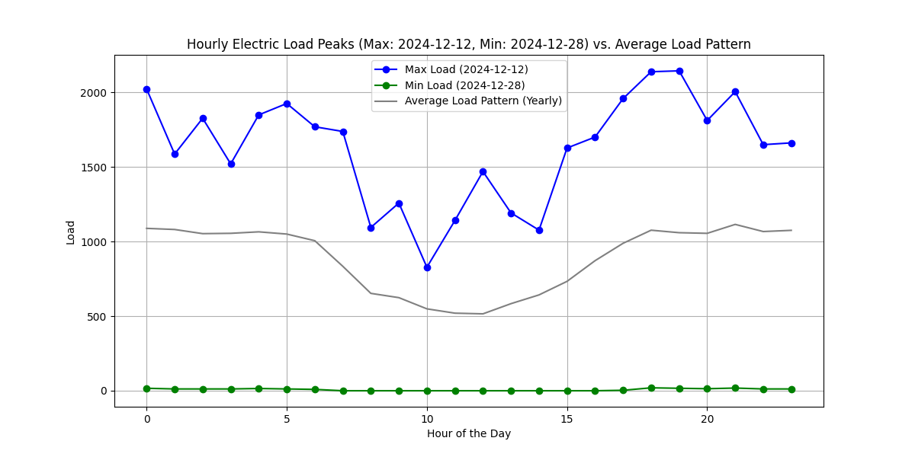

Image: pv curtailed 60 percentile 1,000 kWp.png

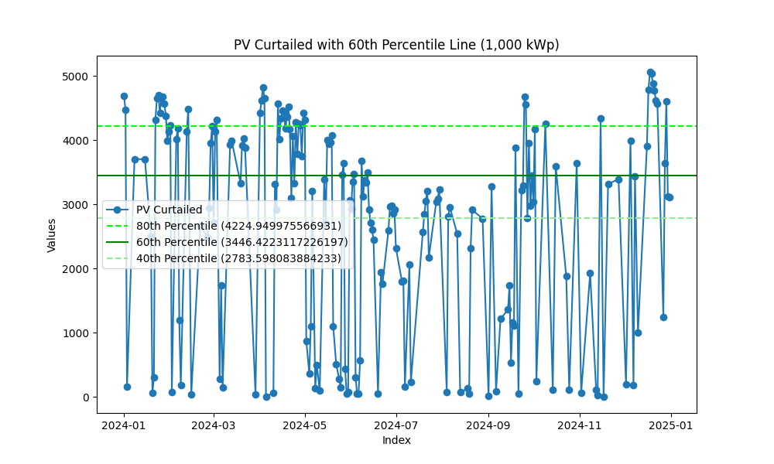

Image: pv curtailed 60 percentile 100 kWp.png

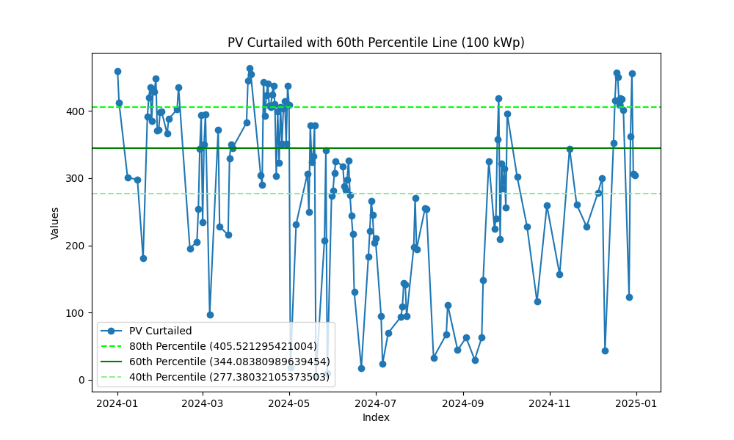

Image: pv curtailed 60 percentile 500 kWp.png

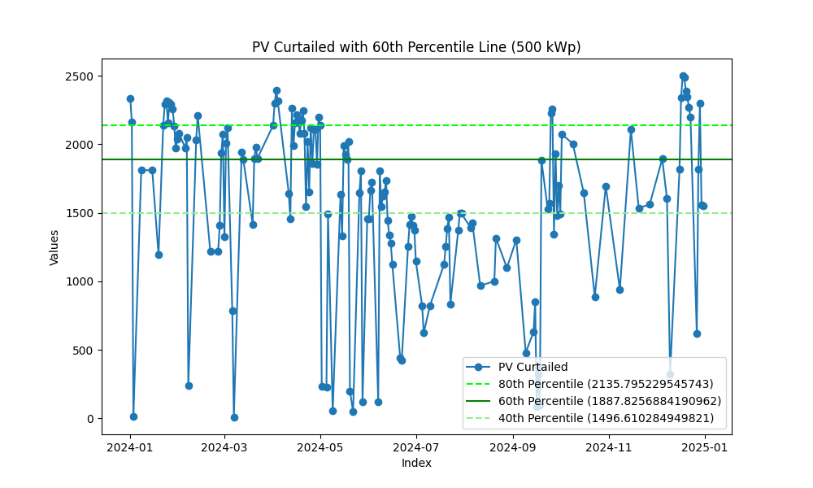

Image: Seasonal.png

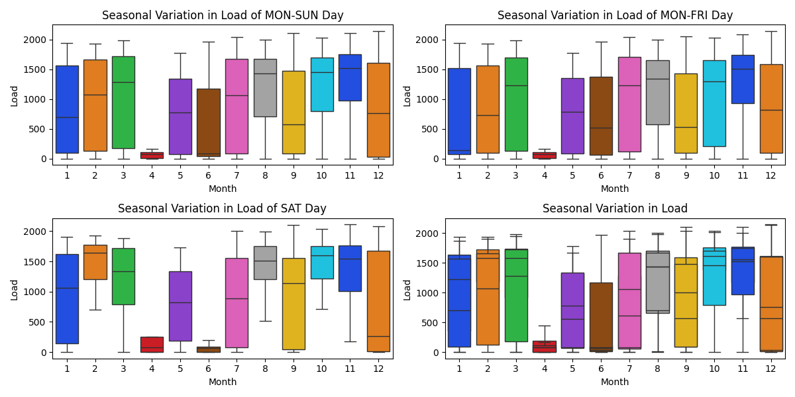

Image: Seasonal_comparison.png

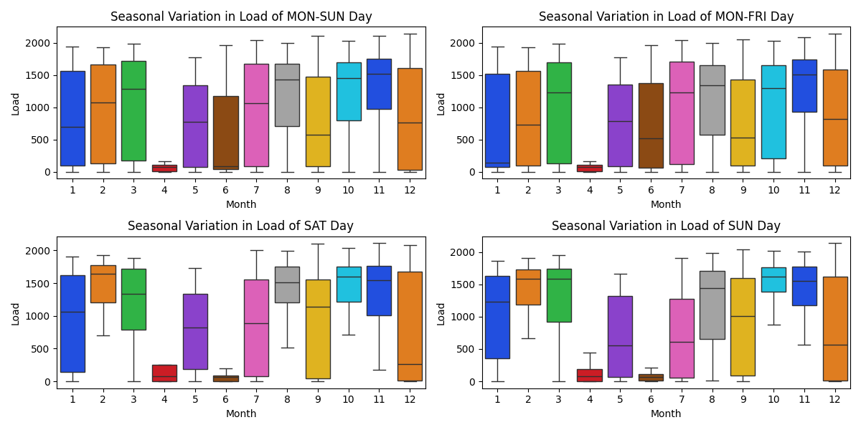

Image: Seasonal_specific_1.png

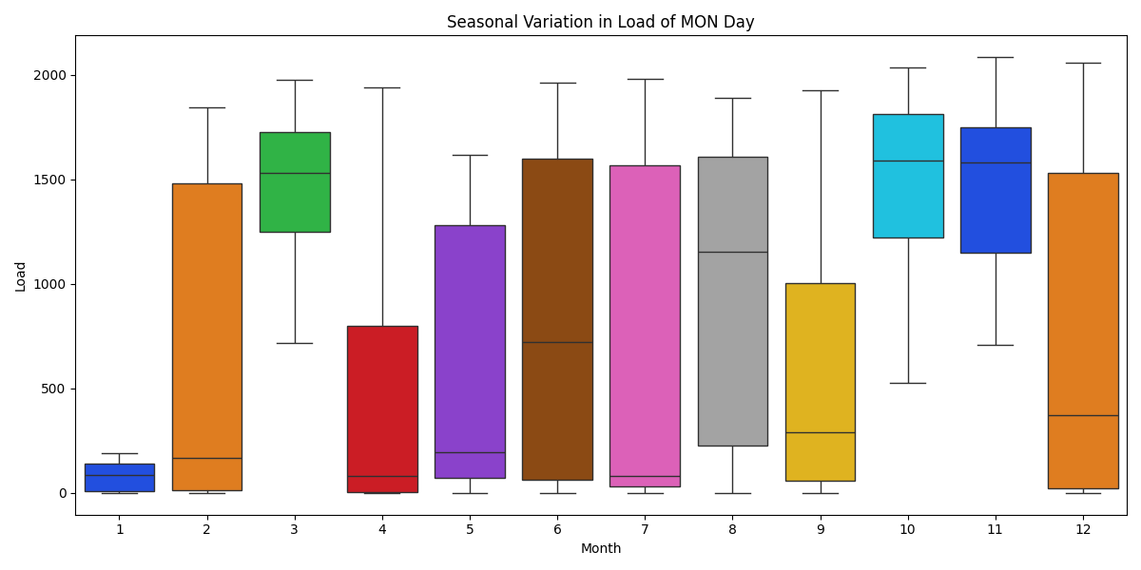

Image: Seasonal_specific_2.png

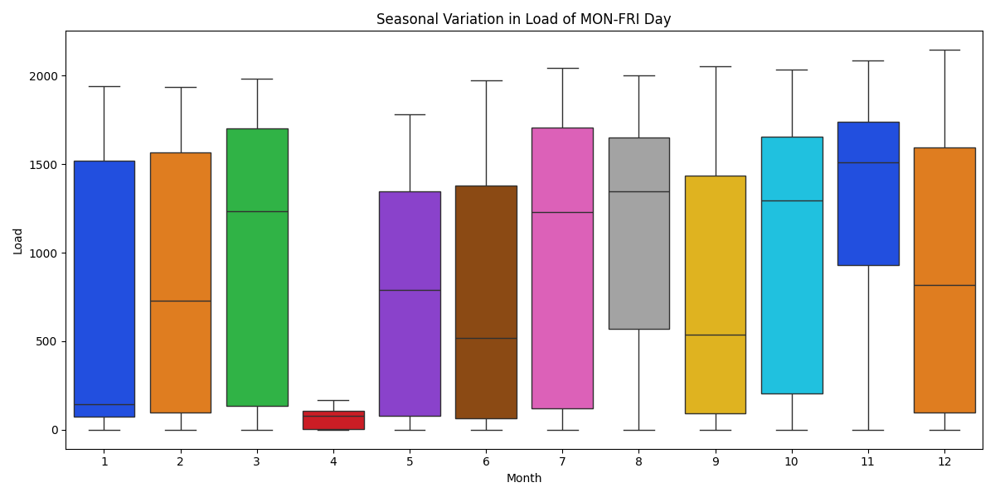

Image: Seasonal_specific_3.png

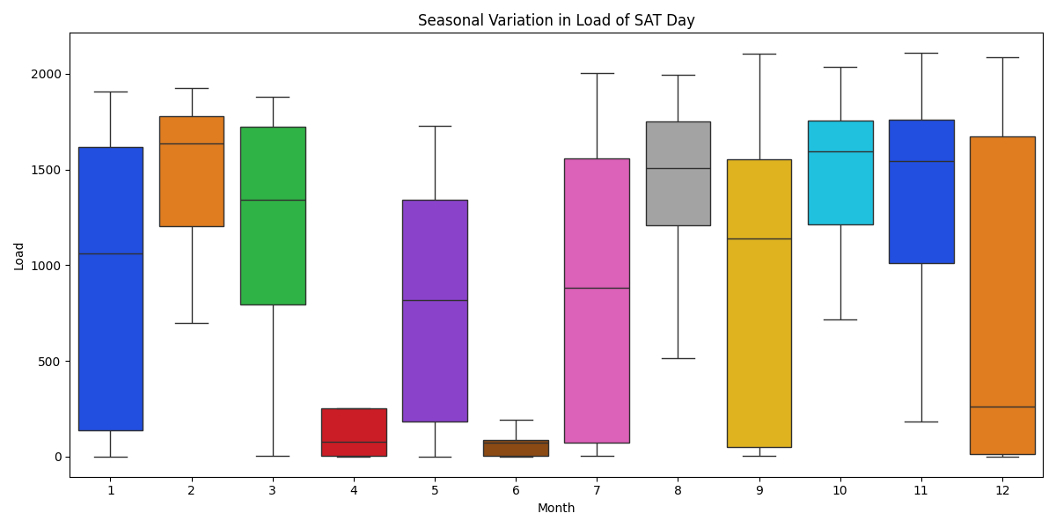

Image: Seasonal_specific_4.png

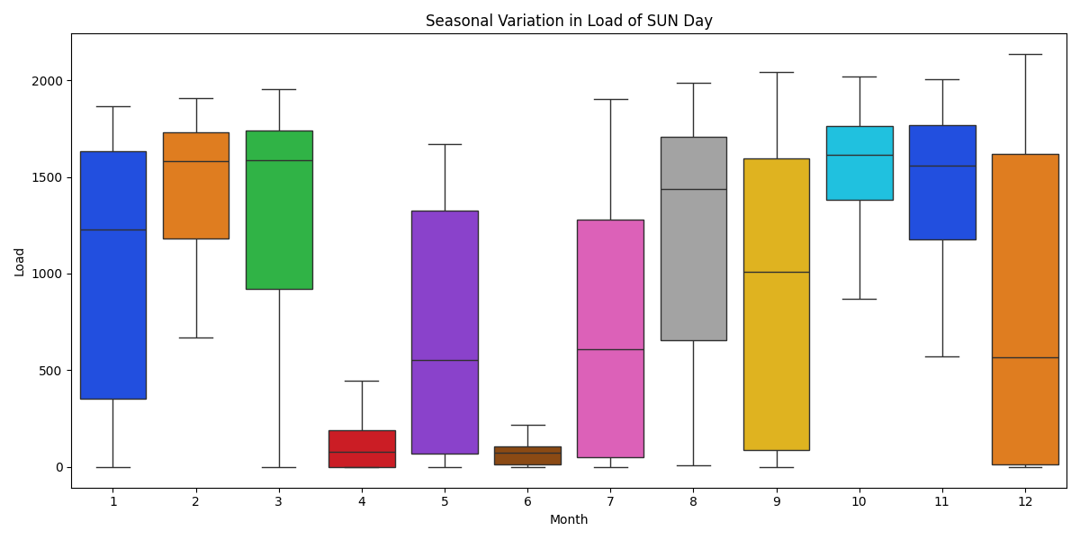

Image: Seasonal_specific_5.png

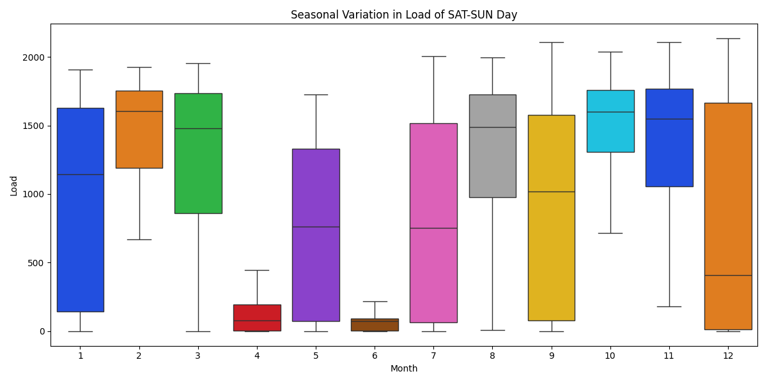

Energy consumption -- Load (kWh)  
1 January: 578,764 kWh, Load Factor: 40.1%  
2 February: 674,580 kWh, Load Factor: 50.0%  
3 March: 806,967 kWh, Load Factor: 54.7%  
4 April: 248,558 kWh, Load Factor: 17.5%  
5 May: 562,084 kWh, Load Factor: 42.5%  
6 June: 387,970 kWh, Load Factor: 27.3%  
7 July: 704,210 kWh, Load Factor: 46.4%  
8 August: 865,464 kWh, Load Factor: 58.1%  
9 September: 545,242 kWh, Load Factor: 36.0%  
10 October: 886,146 kWh, Load Factor: 58.4%  
11 November: 943,860 kWh, Load Factor: 62.2%  
12 December: 616,680 kWh, Load Factor: 38.6%  
  
  
  
Average load factor: 44 %  
  
  
  
Energy of On Peak Data: 2,597,847.00 kWh  
Energy of Off Peak Data: 2,786,530.50 kWh  
Energy of holiday Data: 2,436,148.50 kWh  
Total Energy: 7,820,526.00 kWh  
Sum of all Data: 7,820,526.00 kWh  
Sum of demand_charge: 24,030.00 kW  
  
price_on_peak: 10,869,132.06 THB  
price_off_peak: 13,598,289.31 THB  
price_demand_charge: 3,194,307.90 THB  
Total Electricity Base Price: 27,665,476.16 THB  
 ignore FT & vat  
  
  
On-peak days: 141.9  
Off-peak days: 119.7  
Holiday days: 104.4  
 365 check -> 366.0  
  
  
  
  
PV Install_cap: 100.00 kW  
Energy of pv_produce: 135,513.34 kWh/year (Verify with PVSyst)  
 Monthly average PV energy production (kWh/month): 16,18,18,17,15,13,14,13,14,14,16,16  
Energy of pv_produce: 1,355.13 kWh/kWp/year  
Energy of pv_produce: 3.71 kWh/kWp/day  
Capacity Factor: 15.47 %  
Energy of pv_curtailed: 42,884.72 kWh (31.65 %)  
Energy of pv_serve_load: 92,628.62 kWh  
PR ratio (PV): 0.81  
PR ratio (Load): 0.55  
 pv_serve_load -- On Peak: 56,409.64 kWh  
 pv_serve_load -- Off Peak: 7,295.10 kWh  
 pv_serve_load -- holiday: 28,923.88 kWh  
 CO2 Emission Reduction: 41,868 kg-CO2  
Total Base Price: 435,129.95 THB  
 ignore FT & vat  
  
  
PV < load @9.00: 238 days  
PV > load (in that day): 138 days  
Cycle/year 375 cycles  
5000 Cycle = 13.3 year  
max battery from PV curtailed: 463.47 kWh  
 -- suggest Battery Capacity: 344 kWh  
  
  
 -- installed Battery : 900 kWh  
 -- suggest Battery Saving : 416,475 THB (4,627 THB/kWh/10years)  
 : 38,596 kWh (Curtail 31.65 % -> 3.16 %)  
  
 -- installed Battery : 500 kWh  
 -- suggest Battery Saving : 293,334 THB (5,867 THB/kWh/10years)  
 : 36,182 kWh (Curtail 31.65 % -> 4.95 %)  
  
 -- installed Battery : 400 kWh  
 -- suggest Battery Saving : 246,810 THB (6,170 THB/kWh/10years)  
 : 31,808 kWh (Curtail 31.65 % -> 8.17 %)  
  
 -- installed Battery : 300 kWh  
 -- suggest Battery Saving : 192,214 THB (6,407 THB/kWh/10years)  
 : 25,465 kWh (Curtail 31.65 % -> 12.85 %)  
  
 -- installed Battery : 250 kWh  
 -- suggest Battery Saving : 162,317 THB (6,493 THB/kWh/10years)  
 : 21,664 kWh (Curtail 31.65 % -> 15.66 %)  
  
 -- installed Battery : 200 kWh  
 -- suggest Battery Saving : 131,568 THB (6,578 THB/kWh/10years)  
 : 17,685 kWh (Curtail 31.65 % -> 18.60 %)  
  
 -- installed Battery : 150 kWh  
 -- suggest Battery Saving : 99,990 THB (6,666 THB/kWh/10years)  
 : 13,550 kWh (Curtail 31.65 % -> 21.65 %)  
  
 -- installed Battery : 100 kWh  
 -- suggest Battery Saving : 67,452 THB (6,745 THB/kWh/10years)  
 : 9,212 kWh (Curtail 31.65 % -> 24.85 %)  
  
  
  
  
  
PV Install_cap: 1000.00 kW  
Energy of pv_produce: 1,355,133.39 kWh/year (Verify with PVSyst)  
 Monthly average PV energy production (kWh/month): 161,178,179,172,155,135,136,130,145,138,158,165  
Energy of pv_produce: 1,355.13 kWh/kWp/year  
Energy of pv_produce: 3.71 kWh/kWp/day  
Capacity Factor: 15.47 %  
Energy of pv_curtailed: 528,617.30 kWh (39.01 %)  
Energy of pv_serve_load: 826,516.09 kWh  
PR ratio (PV): 0.81  
PR ratio (Load): 0.49  
 pv_serve_load -- On Peak: 500,233.91 kWh  
 pv_serve_load -- Off Peak: 61,787.82 kWh  
 pv_serve_load -- holiday: 264,494.35 kWh  
 CO2 Emission Reduction: 373,585 kg-CO2  
Total Base Price: 3,953,899.21 THB  
 ignore FT & vat  
  
  
PV < load @9.00: 219 days  
PV > load (in that day): 165 days  
Cycle/year 383 cycles  
5000 Cycle = 13.1 year  
max battery from PV curtailed: 5,063.06 kWh  
 -- suggest Battery Capacity: 3,446 kWh  
  
  
 -- installed Battery : 900 kWh  
 -- suggest Battery Saving : 628,651 THB (6,985 THB/kWh/10years)  
 : 95,669 kWh (Curtail 39.01 % -> 31.95 %)  
  
 -- installed Battery : 500 kWh  
 -- suggest Battery Saving : 364,491 THB (7,290 THB/kWh/10years)  
 : 55,483 kWh (Curtail 39.01 % -> 34.91 %)  
  
 -- installed Battery : 400 kWh  
 -- suggest Battery Saving : 295,926 THB (7,398 THB/kWh/10years)  
 : 45,187 kWh (Curtail 39.01 % -> 35.67 %)  
  
 -- installed Battery : 300 kWh  
 -- suggest Battery Saving : 225,888 THB (7,530 THB/kWh/10years)  
 : 34,632 kWh (Curtail 39.01 % -> 36.45 %)  
  
 -- installed Battery : 250 kWh  
 -- suggest Battery Saving : 190,275 THB (7,611 THB/kWh/10years)  
 : 29,279 kWh (Curtail 39.01 % -> 36.85 %)  
  
 -- installed Battery : 200 kWh  
 -- suggest Battery Saving : 154,083 THB (7,704 THB/kWh/10years)  
 : 23,829 kWh (Curtail 39.01 % -> 37.25 %)  
  
 -- installed Battery : 150 kWh  
 -- suggest Battery Saving : 117,034 THB (7,802 THB/kWh/10years)  
 : 18,198 kWh (Curtail 39.01 % -> 37.67 %)  
  
 -- installed Battery : 100 kWh  
 -- suggest Battery Saving : 79,258 THB (7,926 THB/kWh/10years)  
 : 12,416 kWh (Curtail 39.01 % -> 38.09 %)  
  
  
  
  
  
PV Install_cap: 500.00 kW  
Energy of pv_produce: 677,566.69 kWh/year (Verify with PVSyst)  
 Monthly average PV energy production (kWh/month): 81,89,90,86,77,67,68,65,72,69,79,82  
Energy of pv_produce: 1,355.13 kWh/kWp/year  
Energy of pv_produce: 3.71 kWh/kWp/day  
Capacity Factor: 15.47 %  
Energy of pv_curtailed: 249,283.40 kWh (36.79 %)  
Energy of pv_serve_load: 428,283.30 kWh  
PR ratio (PV): 0.81  
PR ratio (Load): 0.51  
 pv_serve_load -- On Peak: 259,590.93 kWh  
 pv_serve_load -- Off Peak: 32,701.41 kWh  
 pv_serve_load -- holiday: 135,990.96 kWh  
 CO2 Emission Reduction: 193,584 kg-CO2  
Total Base Price: 2,034,410.82 THB  
 ignore FT & vat  
  
  
PV < load @9.00: 223 days  
PV > load (in that day): 150 days  
Cycle/year 372 cycles  
5000 Cycle = 13.4 year  
max battery from PV curtailed: 2,500.78 kWh  
 -- suggest Battery Capacity: 1,888 kWh  
  
  
 -- installed Battery : 900 kWh  
 -- suggest Battery Saving : 605,145 THB (6,724 THB/kWh/10years)  
 : 86,078 kWh (Curtail 36.79 % -> 24.09 %)  
  
 -- installed Battery : 500 kWh  
 -- suggest Battery Saving : 343,188 THB (6,864 THB/kWh/10years)  
 : 49,000 kWh (Curtail 36.79 % -> 29.56 %)  
  
 -- installed Battery : 400 kWh  
 -- suggest Battery Saving : 276,114 THB (6,903 THB/kWh/10years)  
 : 39,514 kWh (Curtail 36.79 % -> 30.96 %)  
  
 -- installed Battery : 300 kWh  
 -- suggest Battery Saving : 208,451 THB (6,948 THB/kWh/10years)  
 : 29,919 kWh (Curtail 36.79 % -> 32.38 %)  
  
 -- installed Battery : 250 kWh  
 -- suggest Battery Saving : 174,217 THB (6,969 THB/kWh/10years)  
 : 25,028 kWh (Curtail 36.79 % -> 33.10 %)  
  
 -- installed Battery : 200 kWh  
 -- suggest Battery Saving : 139,872 THB (6,994 THB/kWh/10years)  
 : 20,122 kWh (Curtail 36.79 % -> 33.82 %)  
  
 -- installed Battery : 150 kWh  
 -- suggest Battery Saving : 105,398 THB (7,027 THB/kWh/10years)  
 : 15,192 kWh (Curtail 36.79 % -> 34.55 %)  
  
 -- installed Battery : 100 kWh  
 -- suggest Battery Saving : 70,512 THB (7,051 THB/kWh/10years)  
 : 10,185 kWh (Curtail 36.79 % -> 35.29 %)

## Images from EPC

Image: Annual Revenue and O&M Cost 100 kW.png

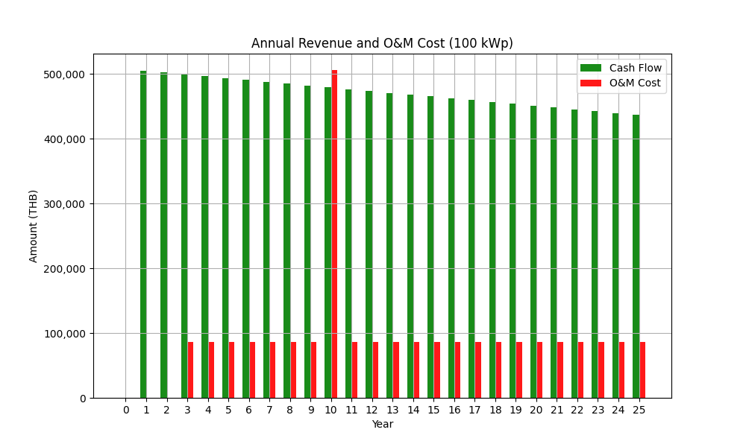

Image: Annual Revenue and O&M Cost 1000 kW.png

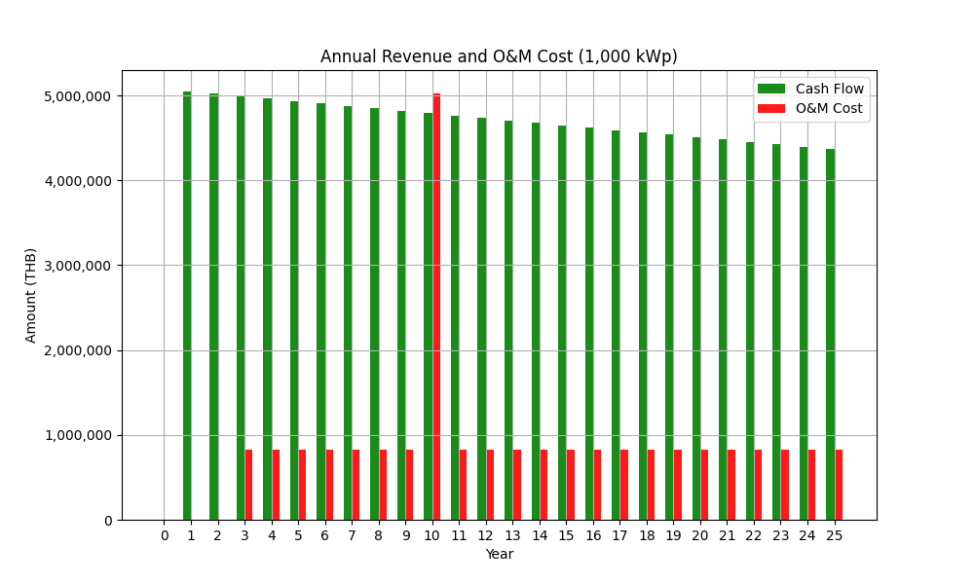

Image: Annual Revenue and O&M Cost 500 kW.png

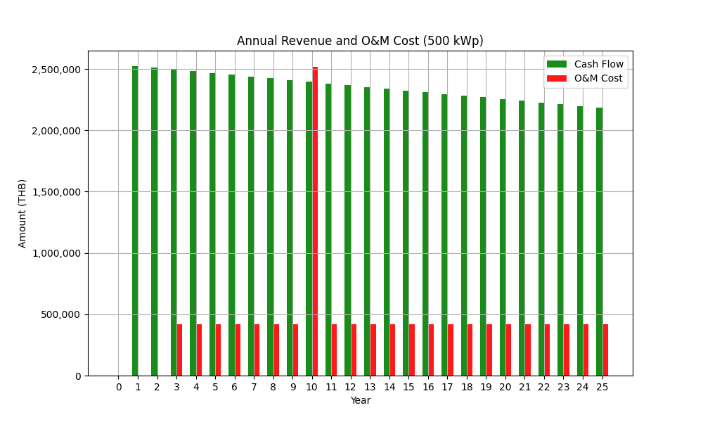

Image: Cumulative Cash Flow 100 kW.png

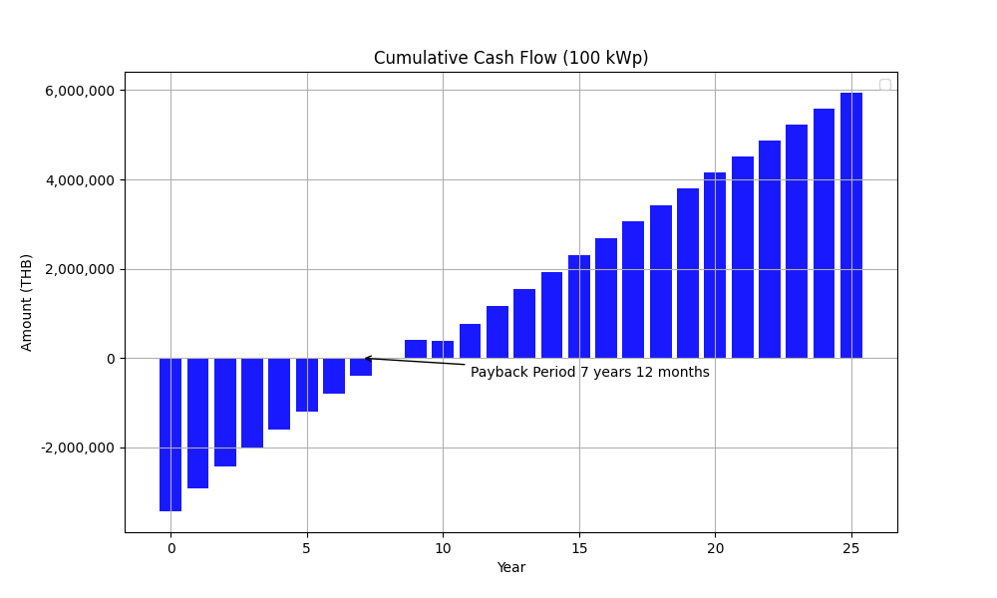

Image: Cumulative Cash Flow 1000 kW.png

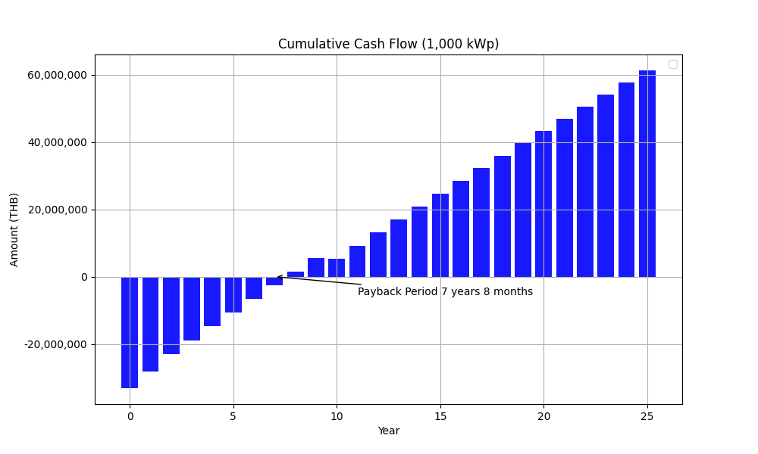

Image: Cumulative Cash Flow 500 kW.png

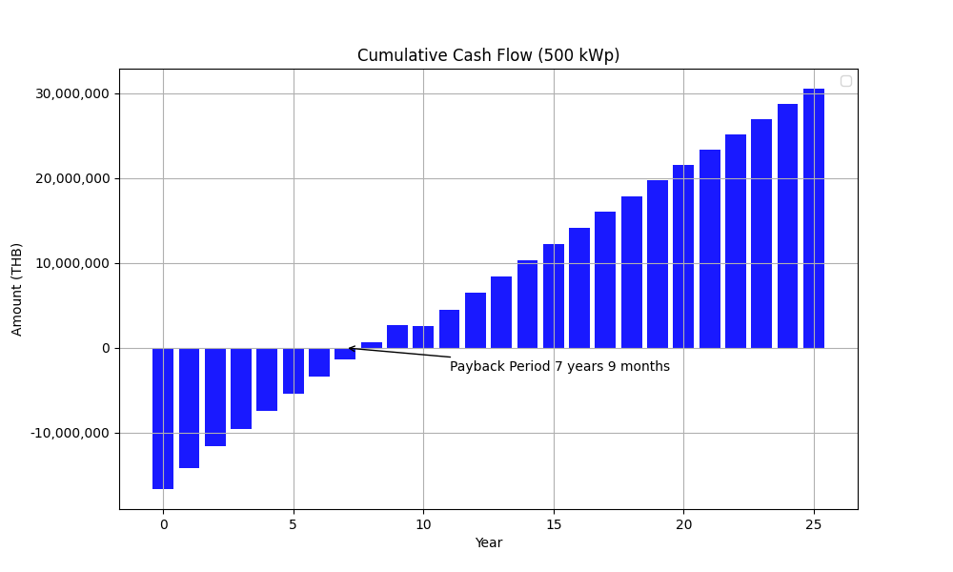

Image: Economic Indicators for Solar PV Project 100 kW.png

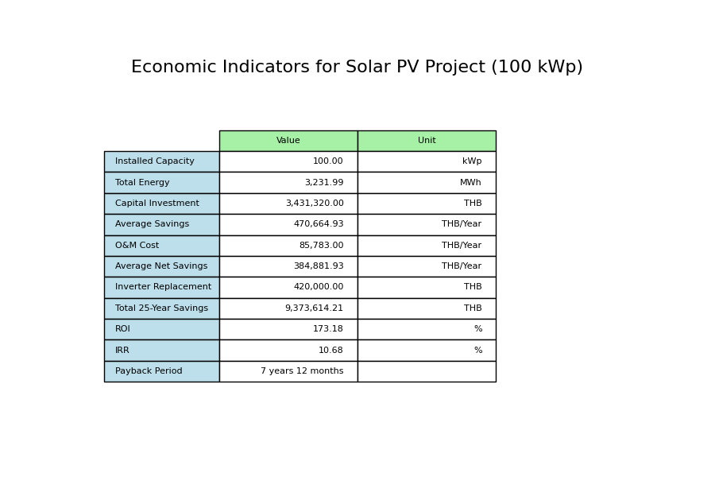

Image: Economic Indicators for Solar PV Project 1000 kW.png

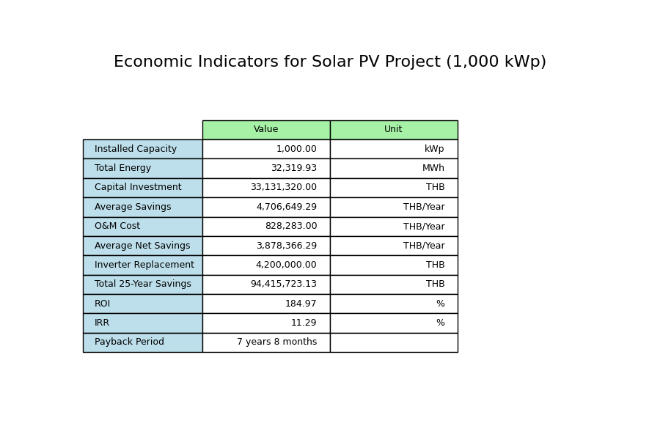

Image: Economic Indicators for Solar PV Project 500 kW.png

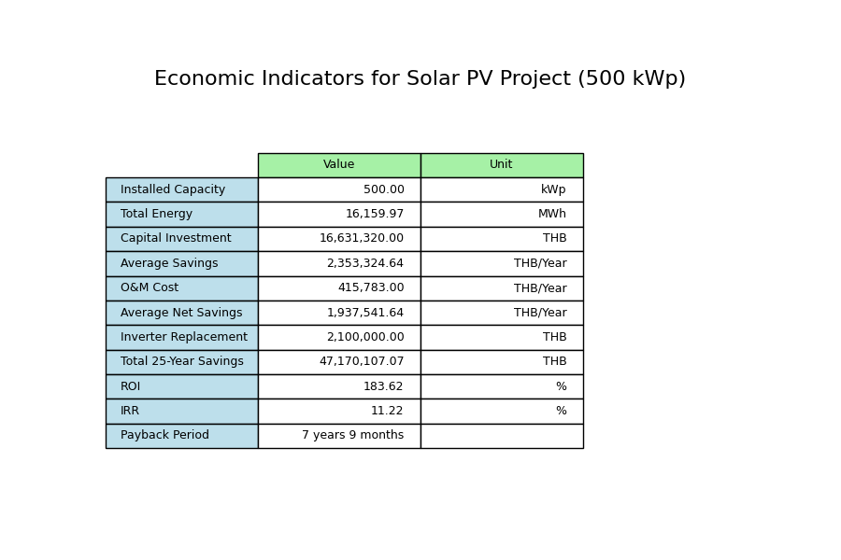

Assumption EPC:  
Tariff Rate Average (with VAT): 3.80000 THB/units  
  
Inputs Configuration:  
Project Time (Years): 25 years  
Cost per kW: 30000.0 THB/kW  
Margin: 10.0 %  
Sale Price per kW: 33000.00 THB/kW  
Solar Degradation First Year: 2.0 %  
Solar Degradation After First Year: 0.55 %  
Inverter Replacement Cost: 4200 THB/kW  
O&M Percentage: 2.5 %  
O&M Escalation Rate: 0.0 %  
O&M Starts at Year: 3  
  
EGAT Operation Cost:  
General Work Cost: 127000 THB  
Distance from EGAT HQ: 160 km  
EGAT Operation Cost: 131320 THB

## Images from GSA

Image: Electricity Cost Comparison 1,000kWp_15.0_15yr.png

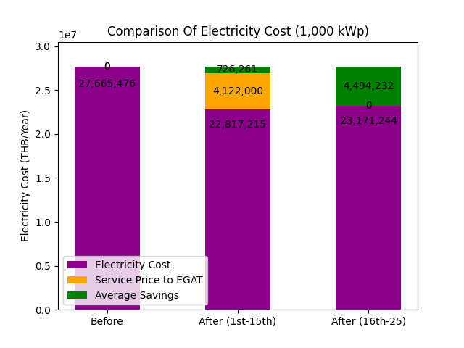

Image: Electricity Cost Comparison 100kWp_15.0_15yr.png

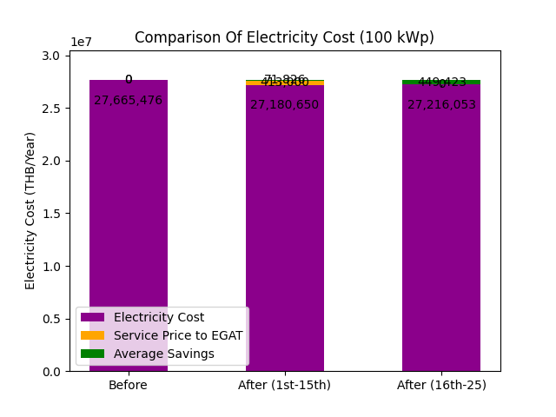

Image: Electricity Cost Comparison 500kWp_15.0_15yr.png

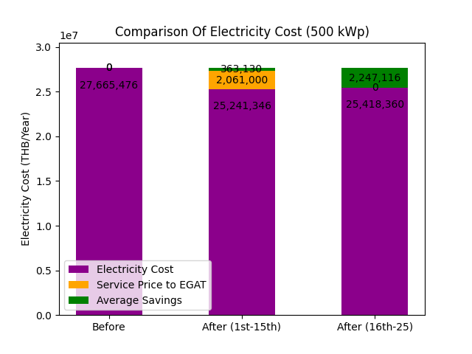

Image: Table image 1,000 kWp 15.0_15 yr.png

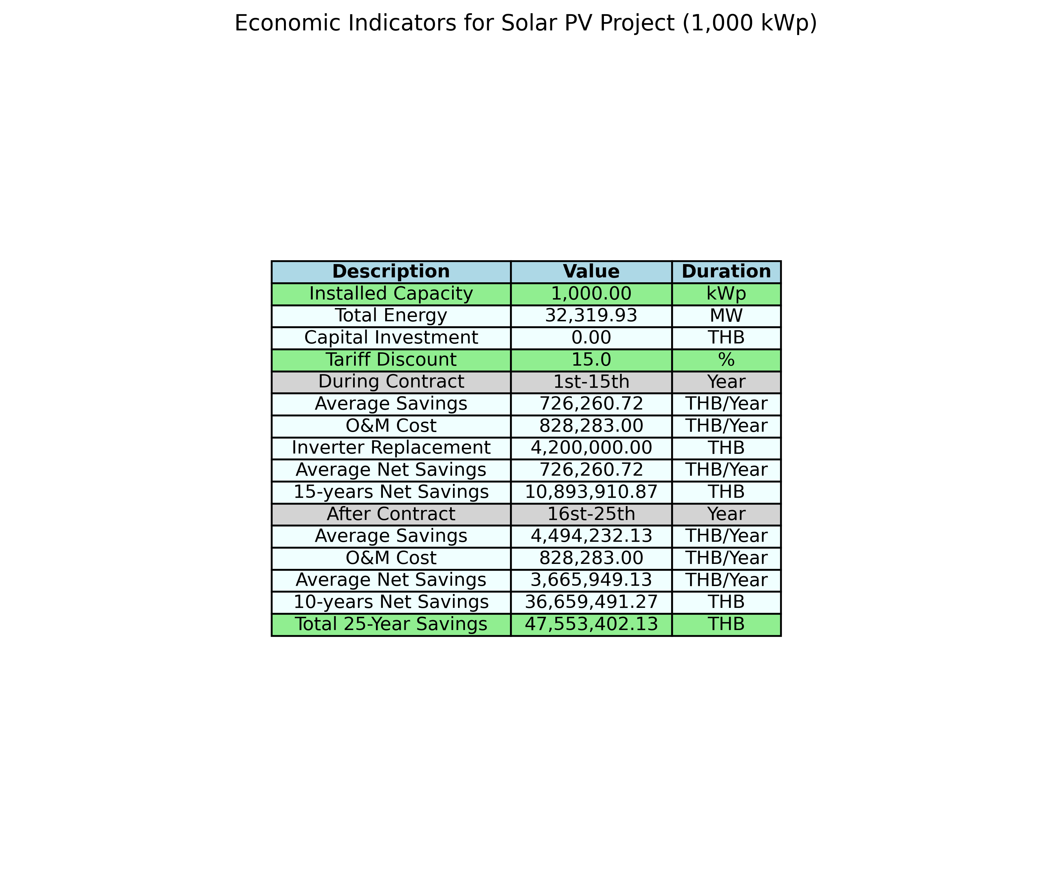

Image: Table image 100 kWp 15.0_15 yr.png

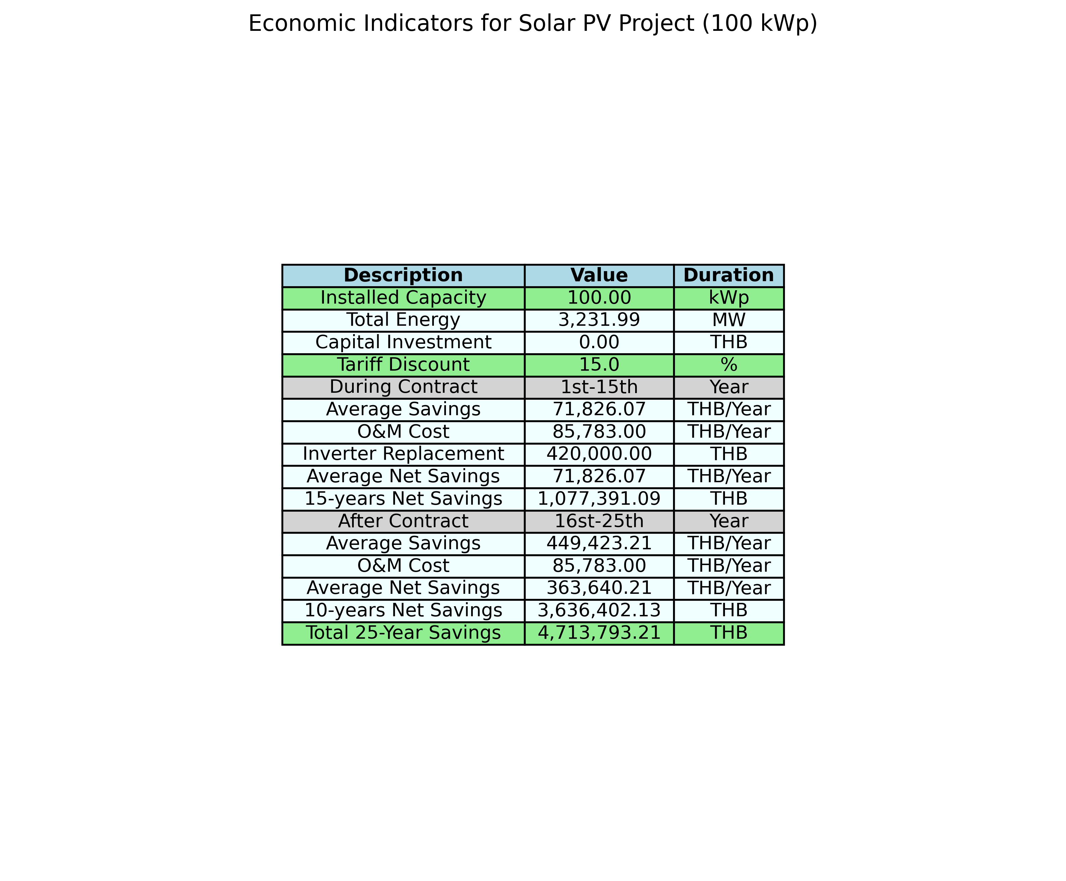

Image: Table image 500 kWp 15.0_15 yr.png

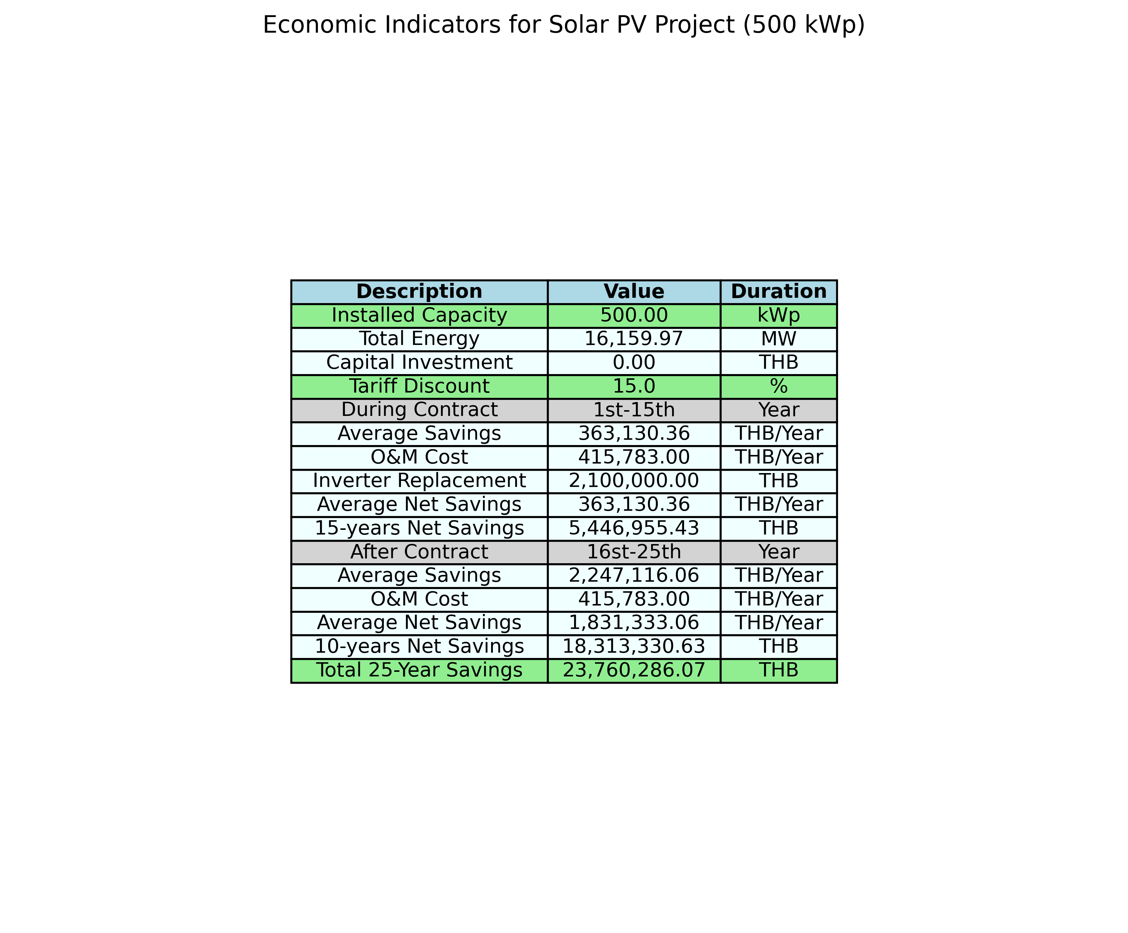

Assumption GSA:  
Tariff Rate Average (with VAT): 3.80000 THB/units  
  
Inputs Configuration:  
Project Time (Years): 25 years  
Cost per kW: 30000.0 THB/kW  
Margin: 10.0 %  
Sale Price per kW: 33000.00 THB/kW  
Solar Degradation First Year: 2.0 %  
Solar Degradation After First Year: 0.55 %  
Inverter Replacement Cost: 4200 THB/kW  
O&M Percentage: 2.5 %  
O&M Escalation Rate: 0.0 %  
O&M Starts at Year: 3  
  
tariff discount: 15.0 % (include FT, exclude VAT)  
contract year = 15 year  
  
EGAT Operation Cost:  
General Work Cost: 127000 THB  
Distance from EGAT HQ: 160 km  
EGAT Operation Cost: 131320 THB